Ontologization of MIABIS Core v3.0 in the Ontology for Biobanking (OBIB)
Structural Analysis of the OBIB Ontology, based on the MIABIS Core Terminology 3rd Version

Abstract
This report documents the ontologization of the Minimum Information About BIobank data Sharing (MIABIS) Core Terminology, 3rd version, into the Ontology for Biobanking (OBIB). It presents a structural, entity-level comparison between the OBIB ontology (baseline, 2023 release) and the updated ontology in which the MIABIS Core v3.0 entities, attributes, and controlled-vocabulary terms have been ontologized. The report quantifies the contribution of the update (125 new classes, 31 new object properties, 41 new controlled-vocabulary individuals, and two renamed classes), documents every newly introduced object property together with its declared domain and range, itemizes every new class, individual, and structural RDF triple with its OBIB identifier, and illustrates the update with diagrams of the ontology metrics, the core MIABIS v3.0 entity relationships, and the new dataset-type hierarchy. It also lists the competency questions the updated ontology is now able to answer. The findings are cross-checked against the terminology and rationale described in Eklund et al. (2024), 'Update of the Minimum Information About BIobank Data Sharing (MIABIS) Core Terminology to the 3rd Version.'

Introduction
Development of the MIABIS biobank-specific terminology was initiated in 2012 by the Biobanking and BioMolecular Resources Research Infrastructure of Sweden (BBMRI), and the first version of MIABIS Core was ontologized in 2013 as Ontologized MIABIS (OMIABIS). Its original purpose was to describe the administrative information of biobanks (administrative entities and their relations) in a form that, at the time, was not systematically represented in any terminology. OMIABIS was an open-source ontology coded in OWL 2.0 and developed according to the principles of the OBO Foundry.
OMIABIS was later merged with a second biobanking ontology to form the current Ontology for Biobanking (OBIB). MIABIS Core was updated to version 2.0 in 2016, covering Biobank, Collection, and Study components, and has since been adopted in biobank registers and catalogues such as the BBMRI-ERIC Directory and the UK CRC Tissue Directory, and integrated into research information management systems such as Molgenis.
Work on MIABIS Core version 3.0 began in 2019 and was completed and published in 2024 (Eklund et al., 2024). Its objective is a higher level of generalization: entities and attributes that are reusable, self-explanatory, and applicable across diverse biobanking contexts, including biobanks holding non-human, environmental, or engineered biological materials, data-driven biobanks, and biobank networks. This report concerns the next step in that lifecycle, the ontologization of MIABIS Core v3.0, i.e., the incorporation of its entities, attributes, and value sets as OWL classes, object properties, and individuals inside OBIB.

Goal of the Report
The primary goal of this report is to document, the contribution made to OBIB during the ontologization of MIABIS Core v3.0. Specifically, this analysis serves three purposes:
- To quantify the structural growth of the ontology (classes, object properties, data properties, annotation properties, individuals) between the baseline and the updated version.
- To document, in full, every new OWL object property, class, and individual introduced during the update, including its identifier, label, and declared domain and range where applicable.
- To document the new classes and individuals introduced to represent MIABIS v3.0 entities and controlled-vocabulary terms, grouped by thematic category, together with any renamed or retired elements.

Report Structure
Section 2 summarizes the scope and rationale of MIABIS Core v3.0 as described in Eklund et al. (2024). Section 3 presents the comparative structural analysis between the two OWL files: overall ontology metrics (3.1), the full list of newly introduced object properties (3.2), newly introduced classes grouped by category (3.3), newly introduced individuals / controlled-vocabulary terms (3.4), renamed classes (3.5), the new axioms (triples) constructed during the update (3.6), the competency questions the updated ontology is now able to answer (3.7), a set of entity-relationship and BFO (Basic Formal Ontology) placement diagrams (3.8), and the broader integration history of OBIB from OMIABIS onward (3.9). Section 4 concludes the report and outlines remaining work. Appendix A lists every newly introduced named class, Appendix B every newly introduced individual, and Appendix C the full set of new structural axioms, each with its OBIB identifier.

MIABIS Core v3.0 — Scope and Rationale
MIABIS Core v3.0 (Eklund et al., 2024) updates the v2.0 entities Biobank, Sample collection (renamed Collection), and Study (renamed Research resource), and introduces a new entity, Network. The update was driven by nine use-cases covering biobank, study, and network types not previously represented in MIABIS, by a 2021 survey of over 500 BBMRI-ERIC biobanks on the services they offer, and by 38 sample/data requests collected from BBMRI-ERIC national nodes to identify researcher-facing terminology gaps.
Four aims guided the update: (1) incorporating data-driven biobanks and data collections, so that Collection and Research resource can describe data derived from samples or donors, not only physical specimens; (2) synchronizing MIABIS Core attributes and value lists with the individual-level Sample, Sample donor and Event components; (3) extending coverage to non-human, environmental and engineered biological materials; and (4) compiling a set of organizational attributes to describe biobank Networks for the first time.
Table 1. Goals, additions, and limitations by MIABIS version.
Version | Goal | Key additions | Remaining limitations
MIABIS v1.0 (2012–2016) | Administrative and aggregate biobank information. | Core components for Samples and Sample Donors. | Human samples only; no Event component; no individual-level detail.
MIABIS v2.0 (2016–2024) | Individual-level interoperability. | Event component; refined Sample / Sample Donor definitions; digital/data-driven biobanks acknowledged. | Non-human samples, environmental/food-derived samples and dataset-level detail not fully addressed; some attributes (quality, clinical data) out of scope.
MIABIS v3.0 (2024) | Generalization and cross-domain applicability. | New entities Biobank(revised), Collection, Research Resource, Network; non-human sample types; quality and dataset attributes; synchronized value lists. | Dataset types, omics and imaging data need further work; optional/null attributes reduce granularity.
MIABIS v3.0 also introduces the Network entity to describe biobank networks, an entity type MIABIS v2.0 had no means to represent, with attributes covering network status, membership, common collaboration topics, and network type. Overall, v3.0 improves precision, interoperability and coverage across entities, adds support for non-human and digital resources, and fills gaps identified in v2.0 while retaining backward-compatible core attributes.

Ontologization Contribution: Comparative Structural Analysis
This section documents the concrete contribution made to the OBIB OWL file while ontologizing MIABIS Core v3.0: the difference between the baseline and the updated ontology.

3.1 Ontology Metrics: Before vs. After
Table 2. Comparative overview of ontology metrics — baseline vs. updated OBIB.
Metric | Baseline | Updated (MIABIS v3.0 ontologized) | Net change
Named classes | 1803 | 1926 | +123 (125 new / 2 removed)
Object properties | 92 | 123 | +31 (31 new / 0 removed)
Data properties | 3 | 3 | 0
Annotation properties | 77 | 77 | 0
Named individuals | 226 | 267 | +41
RDF triples (total statements) | 25892 | 27119 | +1227
The baseline figures (1,803 classes; 92 + 3 + 77 = 172 properties, 226 individuals) match the metrics reported for the 2023 OBIB release, confirming that the supplied baseline file corresponds to that release. The updated file adds 125 new named classes and removes 2 (net +123), adds 31 new object properties with none removed, and adds 41 new individuals. No data or annotation properties were added or removed; the update is concentrated in classes, object properties, and controlled-vocabulary individuals.
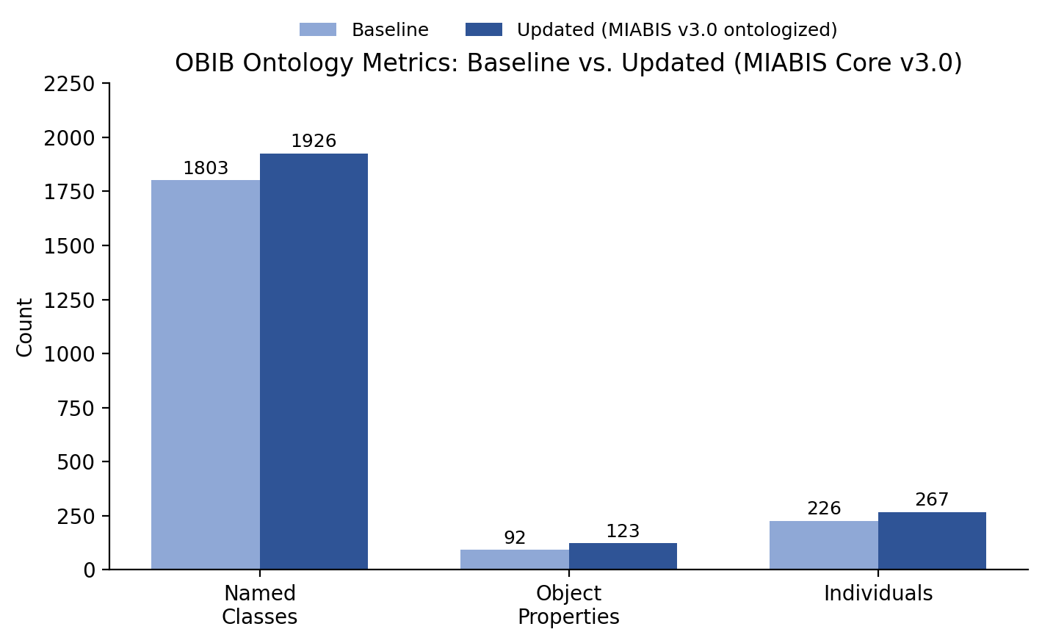
Figure 1. Baseline vs. updated ontology metrics (named classes, object properties, individuals).

3.2 New Object Properties Introduced
All 31 object properties present in the updated ontology but absent from the baseline are listed below, in order of their OBIB identifier. For each property, the table gives its label, the OBIB identifier, and its declared domain and range (where explicitly asserted in the file — properties defined only through anonymous restriction axioms are marked '—').
Table 3. All new object properties introduced while ontologizing MIABIS Core v3.0 into OBIB.
Label | OBIB ID | Domain | Range
has identifier | OBIB_0002019 | — | —
occured at | OBIB_0002021 | event | event date and time
has unit of measurement | OBIB_0002022 | event | age at event unit
has condition | OBIB_0002023 | specimen | use and access conditions
created on | OBIB_0002024 | specimen | sample creation date and time
has biological sex | OBIB_0002025 | — | —
has storage temperature | OBIB_0002026 | — | —
has creation time | OBIB_0002028 | — | —
has url | OBIB_0002029 | — | —
has birth date | OBIB_0002030 | specimen donor | specimen donor date of birth
has anatomical origin | OBIB_0002032 | specimen | anatomical site
has diagnosis | OBIB_0002033 | specimen | sample content diagnosis
has age | OBIB_0002036 | — | age low, age high
has age unit | OBIB_0002039 | — | age low unit, age high unit
sample type | OBIB_0002040 | — | buffy coat specimen, fetal tissue, DNA extract, blood, feces, cancer cell lines, digital sample, embryo, entire body organ
network type | OBIB_0002056 | network | BBMRI-ERIC National Node network, Biobank network, Collection network, Disease-specific network, Project network, Rare Disease network
dataset type | OBIB_0002058 | — | lifestyle dataset, environmental dataset, physiological dataset, biochemical dataset, genomic dataset, clinical dataset, psychological dataset, proteomic dataset, metabolomic dataset, body (radiological) image, whole slide image, photo image, genealogical records
is associated with | OBIB_0002061 | — | —
describes | OBIB_0002063 | — | —
has capability | OBIB_0002064 | — | —
conforms to | OBIB_0002065 | — | —
has location | OBIB_0002066 | — | —
is included | OBIB_0002067 | — | —
included in | OBIB_0002068 | — | —
designed | OBIB_0002069 | — | —
governs | OBIB_0002070 | — | —
has status | OBIB_0002071 | — | —
has number of subjects | OBIB_0002072 | — | —
collected at | obib.owl/OBIB_0002025 | specimen | event
donates | obib.owl/OBIB_0002027 | specimen donor | specimen
sample donor dataset type | obib.owl/OBIB_0002038 | specimen donor | lifestyle dataset, environmental dataset, physiological dataset, biochemical dataset, genomic dataset, clinical dataset, psychological dataset, proteomic dataset, metabolomic dataset, body (radiological) image, whole slide image, photo image, genealogical records
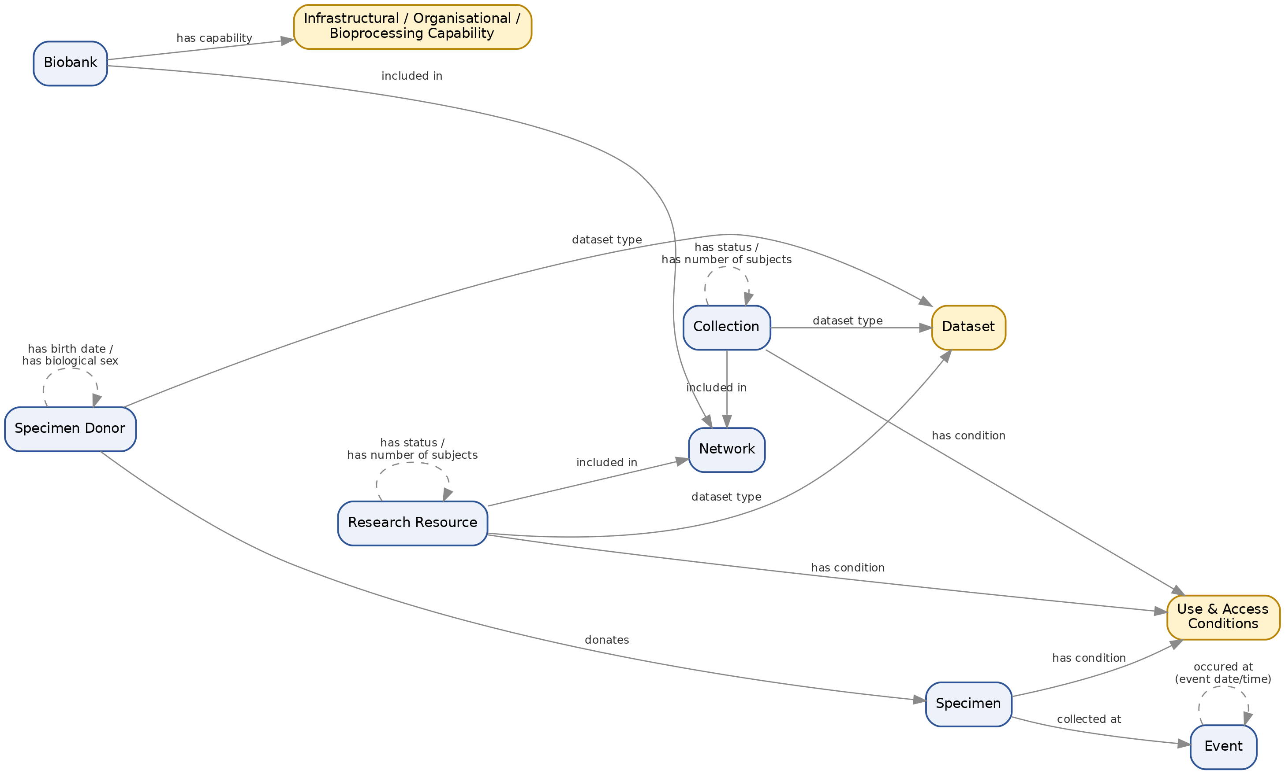
Figure 2. Core MIABIS v3.0 entities connected through a selection of the new object properties.

3.3 New Classes Introduced, by Category
125 new named OWL classes were introduced. The table below groups them by their asserted parent class (a class may appear under more than one category if it has multiple asserted parents); the full list is provided in Appendix A.
Table 4. New classes grouped by thematic category / asserted parent class.
Category (parent class) | New subclasses | Examples
dataset | 13 | lifestyle dataset, environmental dataset, physiological dataset, biochemical dataset, genomic dataset
bioprocessing and analytical capabilities | 11 | Biochemical analyses, Genomics, Nucleic acid extraction, Proteomics, Metabolomics
data item | 9 | contact information, quality management standard, juristic person, country, network status
specimen from organism | 9 | Fibroblasts, Primary cell, Gas exhaled, Isolated or enriched exosomes, Isolated Tumor Cell (neoplastic cell)
specimen | 8 | fetal tissue, Embryo or fetal tissue, Isolated microbes, Post-mortem tissue, cancer cell lines
sample collection setting | 6 | routine health care setting, clinical trials, research study, public health or population based study, museum collection
network | 6 | BBMRI-ERIC National Node network, Biobank network, Collection network, Disease-specific network, Project network
processed specimen | 5 | nasal washing, organoid specimen, Peripheral blood mononuclear cells (PBMC), protein extract, Immortalised cell line specimen
setting datum | 4 | infrastructural capabilities, organisation capabilities, bioprocessing and analytical capabilities, sample collection setting
identifier | 4 | research resource identifier, network name, specimen donor ID, event ID
bodily fluid specimen | 5 | body cavity fluid, Menstrual blood, nasal washing, tears specimen, dental pulp
unique resource locator | 3 | collection unique resource locator, research resource unique resource locator, network unique resource locator
time unit | 3 | age low unit, age high unit, age at event unit
sample source | 3 | animal, human, environment
infrastructural capabilities | 3 | data storage, sample storage, biosafety abilities
Primary cell | 3 | Fibroblasts, Isolated Tumor Cell (neoplastic cell), Peripheral blood mononuclear cells (PBMC)
blood specimen | 3 | Liquid Biopsy, Whole blood, Whole blood, dried (e.g. Guthrie cards)
Tissue (fresh frozen or fixed) | 3 | Tissue (fixed), Tissue (fresh frozen), bone
bone | 3 | bone marrow aspirate, bone marrow plasma, bone tissue
age | 2 | age low, age high
information content entity | 2 | collection or reseach resource status, research resource
object aggregate | 2 | network, collection
frozen specimen | 2 | Tissue (fresh frozen or fixed), Tissue (frozen or FFPE)
tissue | 2 | Embryo or fetal tissue, Post-mortem tissue
bone marrow | 2 | bone marrow aspirate, bone marrow plasma
These categories map directly onto the MIABIS v3.0 additions described in Section 2: the 'dataset' and 'sample source' groups implement the extension to data-driven and non-human biobanking; 'bioprocessing and analytical capabilities', 'infrastructural capabilities' and 'setting datum' implement the new Biobank capability attributes; 'network' implements the new Network entity; and the specimen-related groups ('specimen from organism', 'processed specimen', 'bodily fluid specimen', 'blood specimen', 'bone', 'tissue', etc.) implement the expanded, non-human-inclusive sample-type hierarchy.
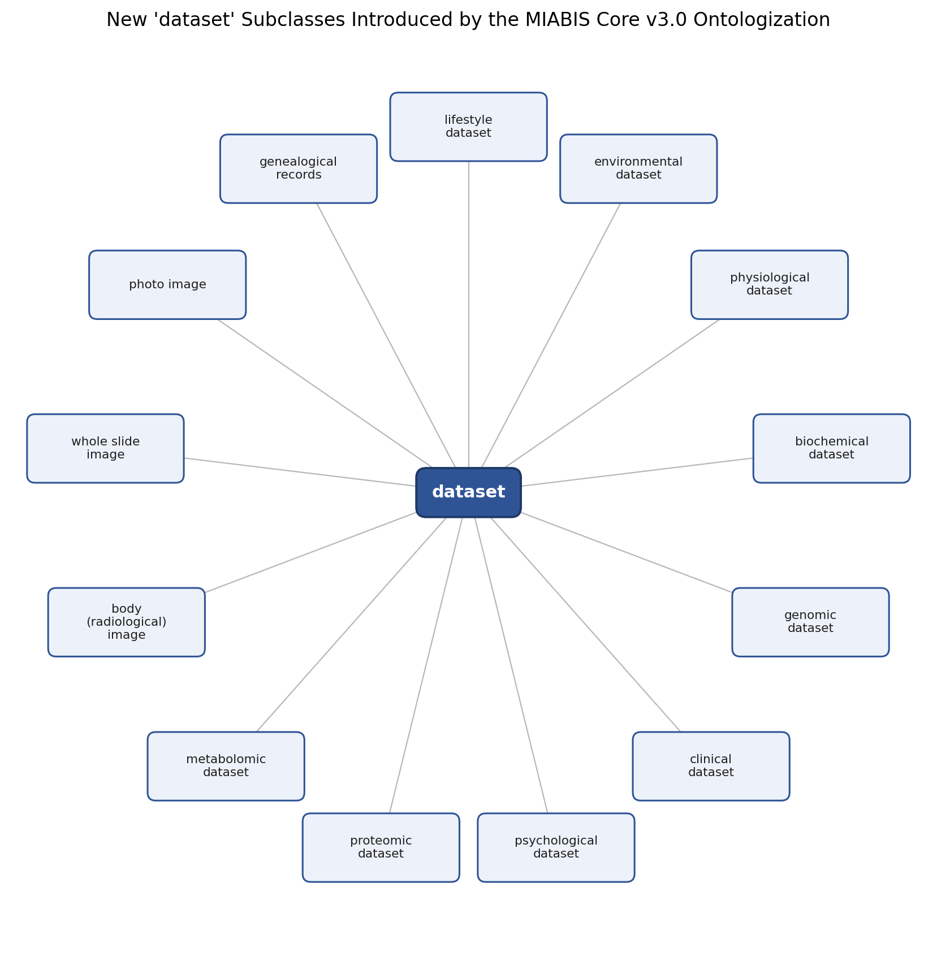
Figure 3. The 13 new subclasses of 'dataset', illustrating the data-driven-biobank extension of MIABIS v3.0.

3.4 New Individuals (Controlled-Vocabulary Terms) Introduced
42 new named individuals were introduced, populating the enumerated value lists (controlled vocabularies) of the new and updated MIABIS v3.0 attributes. The table below groups them by value list; the full, itemized list of all 42 individuals with their OBIB identifiers is provided in Appendix B.
Table 5. New individuals grouped by controlled-vocabulary value list.
Value list (rdf:type) | Count | New values
collection design | 12 | Case-control, Cross-sectional, Longitudinal cohort, Twin-study, Quality control study, Population-based cohort, Reference collection, Disease-specific cohort, Birth cohort, disease collection, Microbial collection, Rare
organisation capabilities | 9 | Recontact with donors, Facilitating clinical trials, Setting up prospective collections, Access to omics data, Access to laboratory analysis data, Access to donors'clinical data, Access to pathology archive, Access to radiology archive, Access to national medical registries
common collaboration topics | 9 | Common charter, Common SOPs, Common data access policy, Common sample access, policy, Common MTA, Common image MTA, Common representation, Common URL
use and access conditions | 7 | Commercial use, Collaboration, Specific research use, Genetic data use, Outside EU access, Xenograft, Other animal work
quality management standard | 2 | ISO 20387, ISO 9001
collection or reseach resource status | 2 | Active, Ended
infrastructural capabilities | 1 | Other

3.5 Renamed Classes
In addition to new elements, the update renames two Specimen Donor attribute classes.
Table 6. Renamed classes.
Baseline element (ID) | Updated element (ID) | Note
specimen donor's date of birth (OBIB_0000482) | specimen donor date of birth (OBIB_0002034) | Renamed and re-scoped as the range of the new object property 'has birth date'.
donor's biological sex (OBIB_0000483) | donor biological sex (OBIB_0002020) | Renamed and re-scoped as the range of the new object property 'has biological sex'.

3.6 New Axioms (Triples) Constructed
Every new class, object property, and individual is defined in the ontology by a set of RDF triples (subject–predicate–object statements). Between the baseline and the updated file, 475 new structural triples were constructed for the new/renamed entities documented in this report — declarations (rdf:type), class-hierarchy statements (rdfs:subClassOf), property-hierarchy statements (rdfs:subPropertyOf), and domain/range assertions (rdfs:domain / rdfs:range). Purely lexical annotation triples (labels, textual definitions, comments) are not counted here, as their content is already reflected in the Label columns of Tables 3–5. Table 7 summarizes the new triples by predicate; the complete, itemized list — each triple given as Subject (ID) | Predicate | Object (ID) — is provided in Appendix C.
Table 7. New structural triples, by predicate.
Predicate | Count | Meaning
rdf:type | 262 | Declares the OWL type of a new entity (owl:Class, owl:ObjectProperty, owl:NamedIndividual, or the controlled-vocabulary class of an individual).
rdfs:subClassOf | 142 | Places a new class under its parent class in the hierarchy.
rdfs:subPropertyOf | 6 | Places a new object property under its parent (more general) property.
rdfs:domain | 11 | Asserts the domain (subject type) of a new object property.
rdfs:range | 54 | Asserts the range (object type) of a new object property.
owl:inverseOf | 1 | Declares a new object property as the inverse of another property.
In total, together with the lexical (label/definition) triples that accompany each entity, these axioms account for the +1216 net growth in RDF triples reported in Table 2.

3.7 Competency Questions
A competency question is a natural-language question that an ontology, together with its instance data, should be able to answer via a query over its class hierarchy, object properties, and individuals. Thanks to the classes, object properties, and individuals introduced in this update, the ontology is now in a position to answer the following competency questions, which it could not answer against the pre-update baseline:
- What is the network type of a given Network, and which Biobanks or Collections are included in it?
- What datasets (by dataset type) are associated with a given Collection, Research Resource, or Specimen Donor?
- What Use & Access conditions govern a given Collection, and what condition applies to a given specimen?
- What is the storage temperature of a given specimen?
- What is the biological sex and date of birth of a given Specimen Donor?
- At which Event was a given specimen collected, and when did that Event occur?
- Which specimens has a given Specimen Donor donated?
- What infrastructural, organisational, or bioprocessing/analytical capabilities does a given Biobank offer?
- What is the current status (e.g., Active, Ended) of a given Collection, Research Resource, or Network?
- What is the total number of subjects recorded for a given Collection or Research Resource?
- What quality management standard (e.g., ISO 20387, ISO 9001) does a given Biobank conform to?
- What is the anatomical origin and sample-content diagnosis associated with a given specimen?
Each question above corresponds directly to one or more of the object properties in Table 3 (e.g., 'network type', 'dataset type', 'has condition', 'has storage temperature', 'collected at', 'donates', 'has capability', 'has status', 'has number of subjects', 'conforms to') and the controlled-vocabulary individuals in Table 5 / Appendix B.

3.8 Ontology Diagrams: Core Entities and Their BFO Placement
This section complements Figure 2 with a BFO (Basic Formal Ontology) placement diagram for its entities, and with three additional entity-relationship diagrams that zoom into specific parts of the model — the individual-level components (Specimen, Specimen Donor, Event), the organizational components (Biobank, Collection, Research Resource, Network), and the sample-type class hierarchy — each followed by a diagram showing where its core class(es) sit within the BFO upper ontology. Grey boxes denote pre-existing BFO/IAO/OBI upper-level classes; blue boxes denote the core MIABIS v3.0 entities; green boxes in Figure 9 denote classes newly introduced by this ontologization.
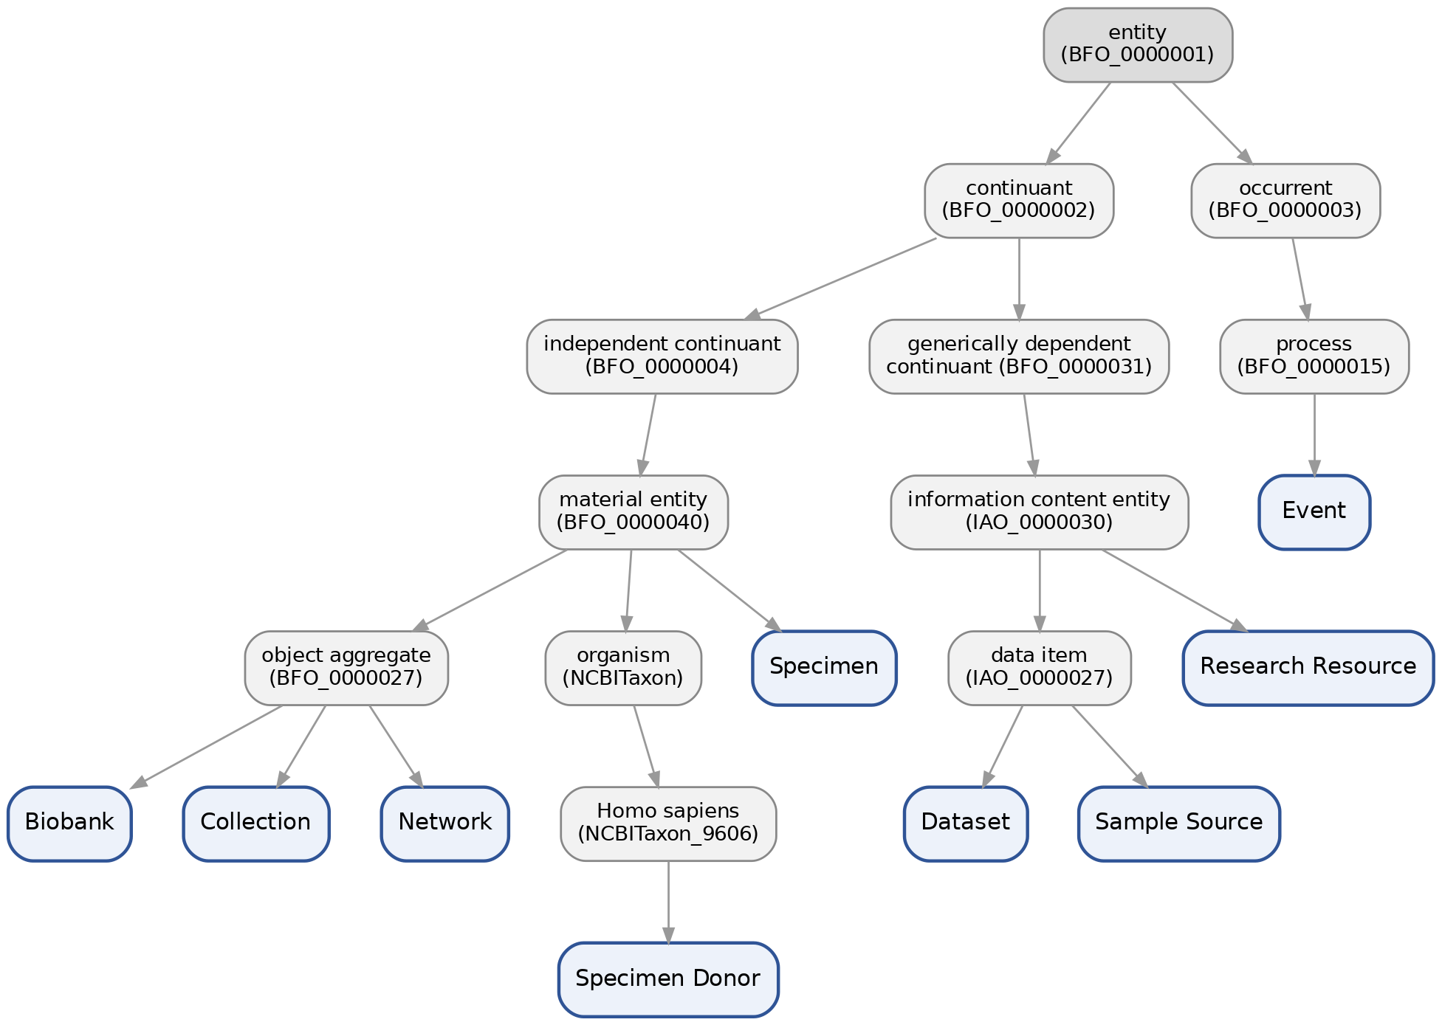
Figure 4. BFO parent-class tree for the Figure 2 entities (Biobank, Collection, Research Resource, Network, Specimen, Specimen Donor, Event, Dataset, Sample Source).

Sample, Sample Donor, and Event
Figure 5 details the individual-level component of the model — Specimen (Sample), Specimen Donor, and Event — together with the attribute-value classes reached through the new object properties in Table 3.
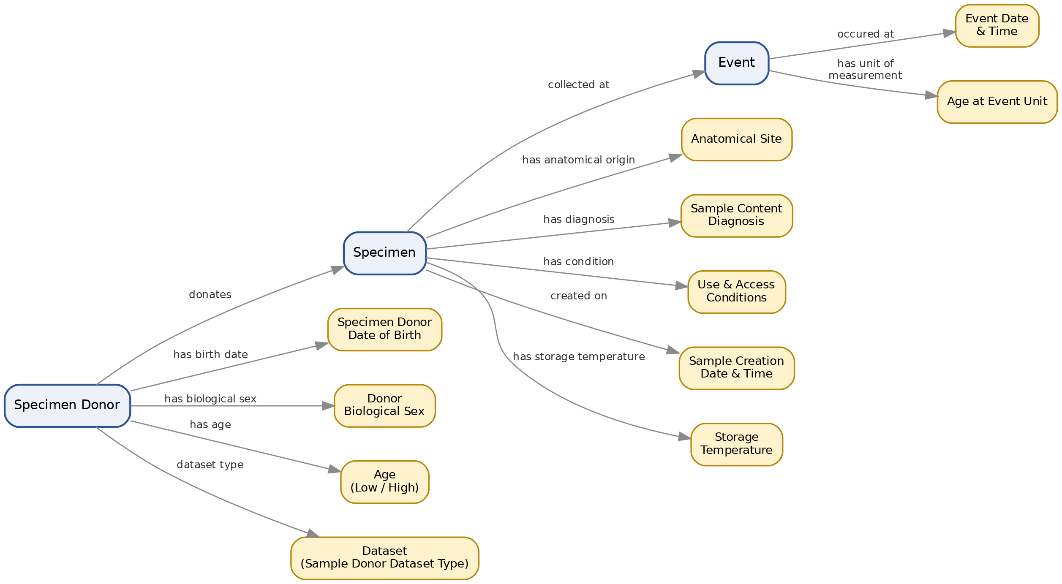
Figure 5. Specimen, Specimen Donor, and Event entities and their relationships.
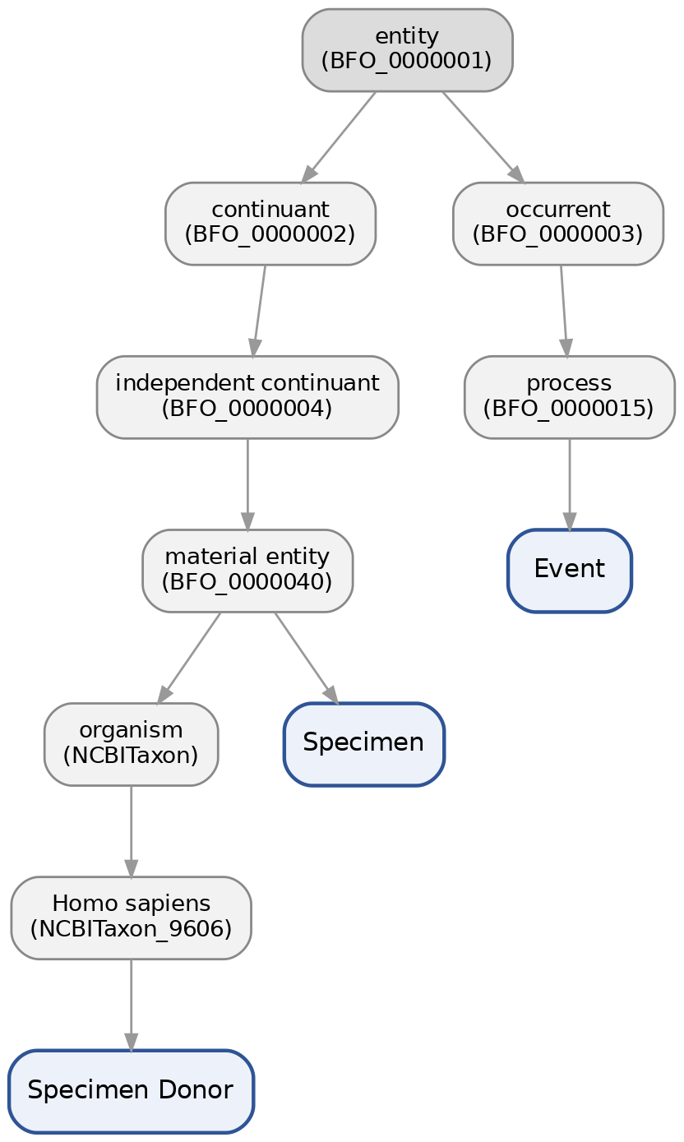
Figure 6. BFO parent-class tree for Specimen, Specimen Donor, and Event. Specimen Donor is placed under organism (Homo sapiens); Event is a process (occurrent); Specimen is a material entity.

Biobank, Collection, Research Resource, and Network
Figure 7 details the organizational component of the model (the four top-level MIABIS v3.0 entities) together with the attribute-value classes reached through the new object properties in Table 3.
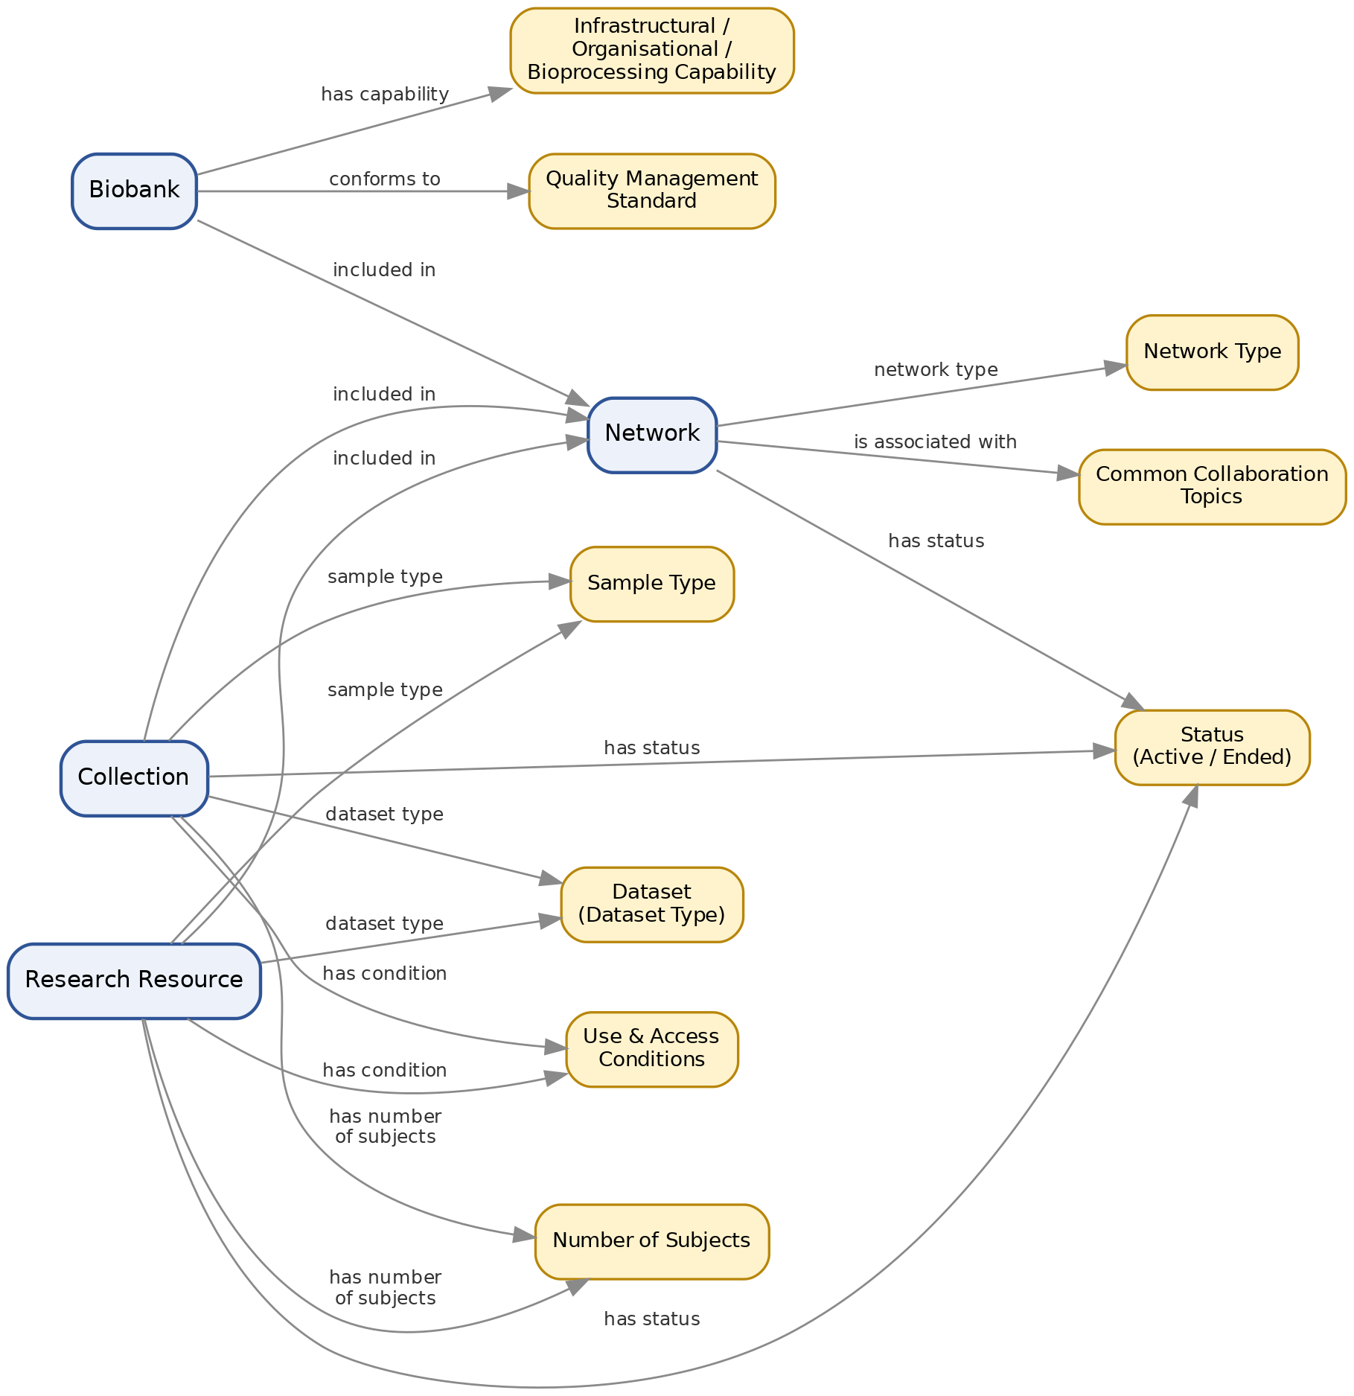
Figure 7. Biobank, Collection, Research Resource, and Network entities and their relationships.
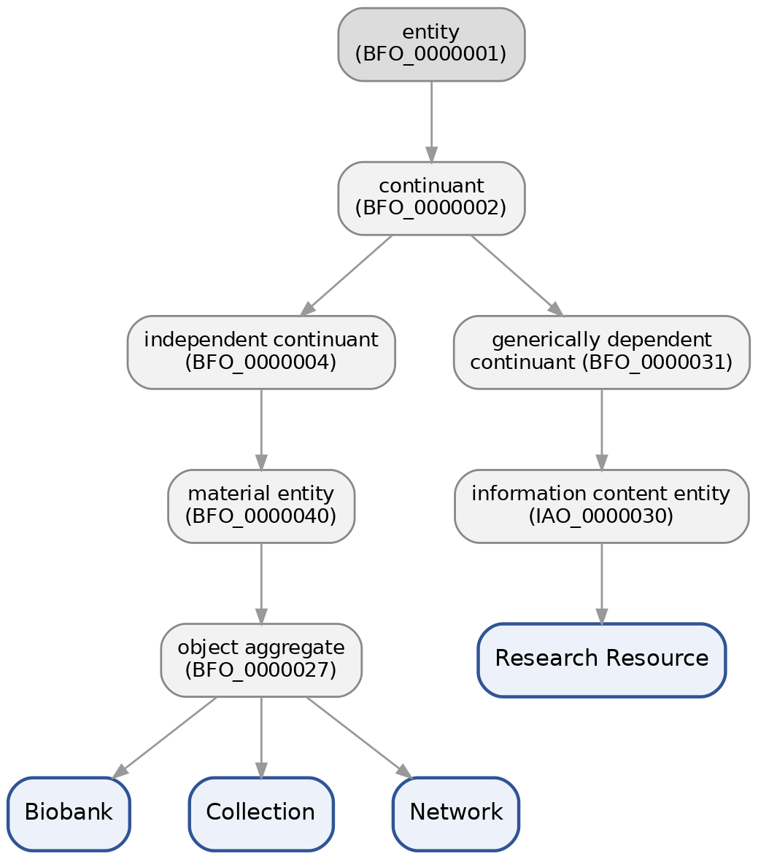
Figure 8. BFO parent-class tree for Biobank, Collection, Research Resource, and Network. Biobank, Collection, and Network are object aggregates (material entities); Research Resource is an information content entity.

Sample Types
Figure 9 expands on Figure 3 by showing the full class hierarchy under 'specimen' that carries the new, non-human-inclusive sample-type coverage introduced by MIABIS v3.0, the values reachable through the 'sample type' object property in Table 3. New classes introduced by this ontologization are shown in green, pre-existing OBI classes that they attach to are shown in grey.
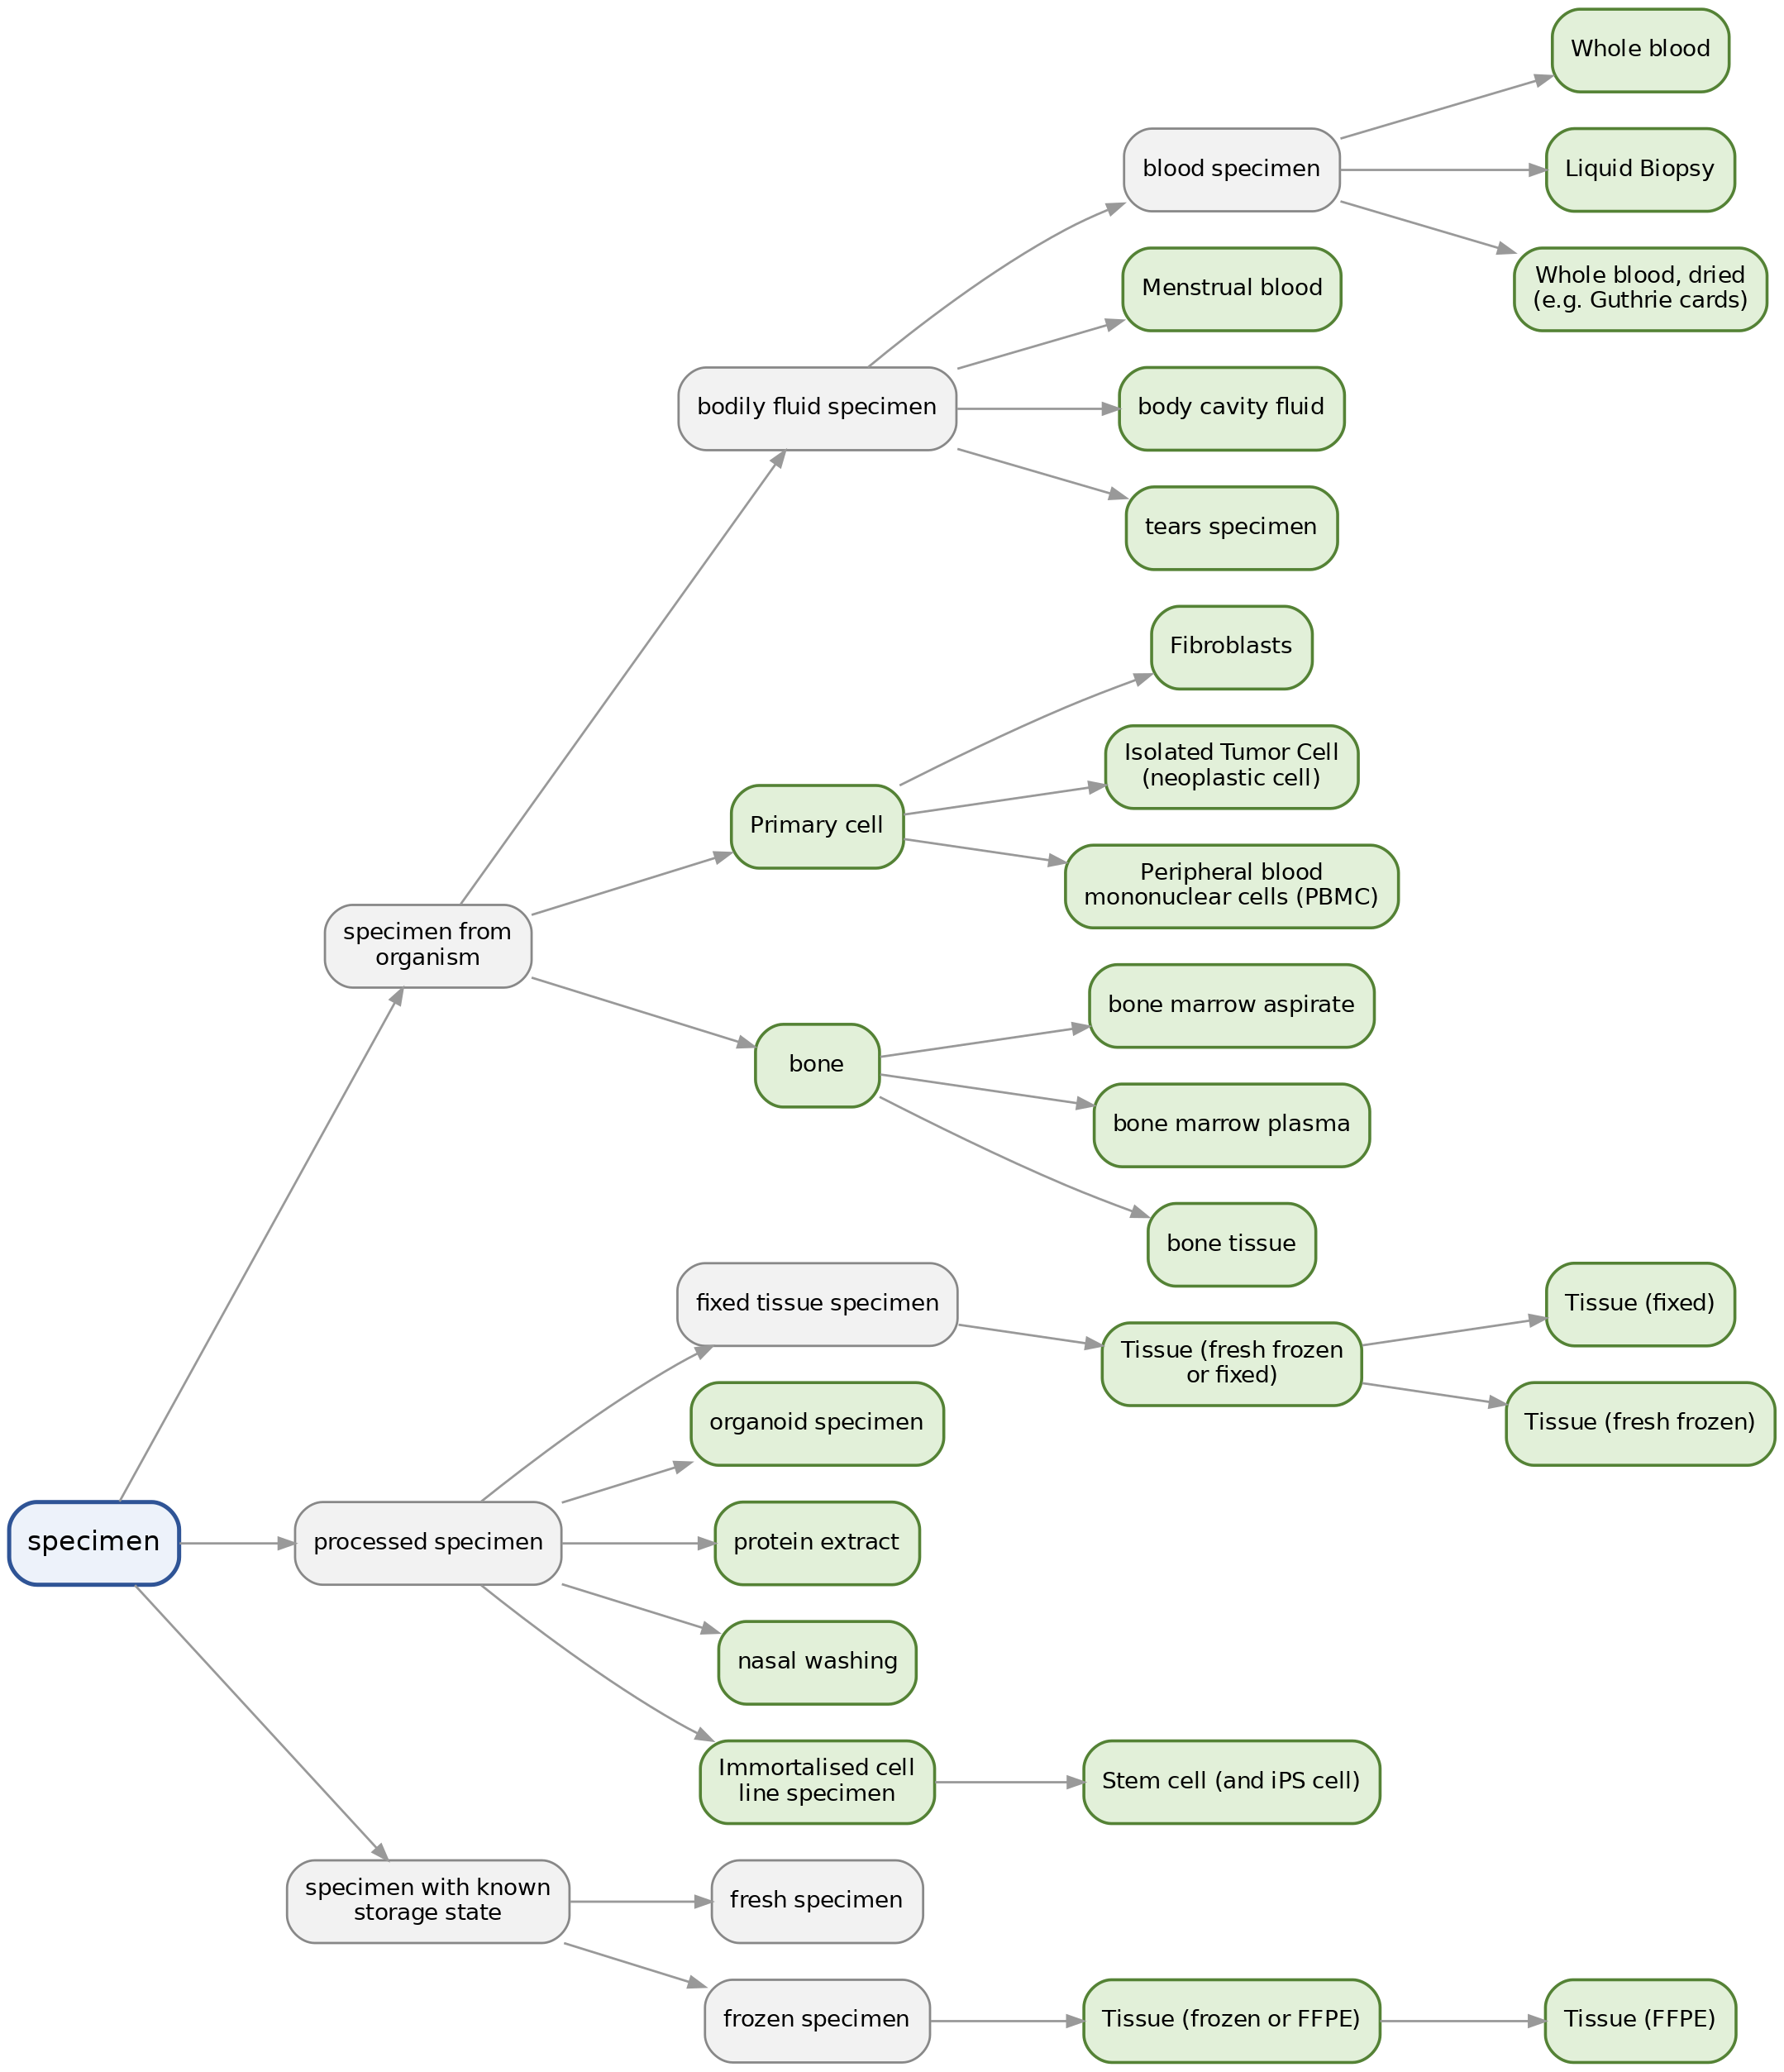
Figure 9. Sample (specimen) type hierarchy, showing new classes (green) attached to pre-existing OBI branches (grey).
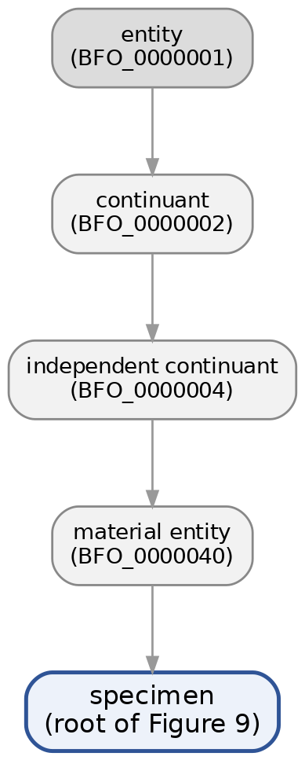
Figure 10. BFO parent-class tree for 'specimen', the root of the Figure 9 hierarchy: specimen is a material entity via the restriction 'material entity and (has role some specimen role)'.

3.9 Integration: From OMIABIS to OBIB
The development of OBIB was based on the principle of reusing established terms, a critical step in ensuring semantic interoperability in the biobanking domain. The OMIABIS ontology initially consisted of 246 classes, 46 properties, and 34 axioms. However, OMIABIS could not on its own serve interoperability, so the Ontology for Biobanking (OBIB) was generated. OBIB is based on a subset of the Ontology for Biomedical Investigation (OBI), has the Basic Formal Ontology (BFO) as its upper ontology, and is developed following OBO Foundry principles. The first version of OBIB resulted from the merging of two existing biobank-related ontologies, OMIABIS and the Biobank Ontology (BO).
The OBIB ontology was later extended with additional biobank-related ontologies, such as the Phenotype and Trait Ontology (PATO), the Cell Ontology (CL), the NCBI Organismal Classification (NCBITAXON), and many more ontologies that each serve a different and important role in biobanking, and thus OBIB’s ontology structure grew significantly. More concretely, these integrations progressively introduced new subgraphs along with their corresponding axioms, based on the needs of the ontology. Table 8 below shows this evolution, from the original OMIABIS ontology, through the first merged OBIB release (2016), to the OBIB baseline (2023) used as the starting point for the MIABIS Core v3.0 ontologization documented in this report.
Table 8. Comparative overview of ontology metrics across OMIABIS and OBIB versions.
Ontology | Classes | Properties | Individuals | Axioms
OMIABIS (2013) | 249 | 64 | — | 34
OBIB (2016) | 516 | 83 | — | 1,172
OBIB (2023) | 1,803 | 172 | 226 | 17,807
OBIB (2026) | 1,926 | 203 | 267 | 27,119
The OBIB (2023) row is the baseline against which the MIABIS Core v3.0 ontologization documented in this report (Sections 3.1–3.8) was measured. The final row, OBIB (2026), reports the metrics of the updated ontology after this ontologization work (1,926 classes; 123 object + 3 data + 77 annotation = 203 properties; 267 individuals; 27,119 RDF triples, used here as a proxy for axioms, consistent with the RDF-triples metric in Table 2), confirming continuity between OBIB’s broader integration history and the update presented here.

Conclusion and Future Work
The ontologization of MIABIS Core v3.0 into OBIB is a measurable, well-scoped structural update: 125 new classes, 31 new object properties, 41 new controlled-vocabulary individuals, and two class renamings, with no removals among object properties. The new elements map directly onto the four aims of MIABIS Core v3.0 — data-driven biobank support, synchronization with the individual-level Sample/Sample donor/Event components, non-human and environmental sample coverage, and the new Network entity, confirming that the update faithfully implements the terminology defined in Eklund et al. (2024).
Future work should focus on: (a) adding formal textual definitions (IAO_0000115) to the newly introduced object properties, most of which currently carry only a label; (b) completing explicit rdfs:domain/rdfs:range assertions for the object properties that are currently constrained only through anonymous OWL restrictions; (c) running a full OWL reasoner (e.g., HermiT or ELK) over the updated ontology to confirm logical consistency and satisfiability of all new class hierarchies; and (d) extending dataset-type and sample-type coverage further as omics and imaging data modelling matures in future MIABIS revisions.

References
Brochhausen M, Fransson MN, Kanaskar NV, Eriksson M, Merino-Martinez R, Hall RA, Norlin L, Kjellqvist S, Hortlund M, Topaloglu U, Hogan WR, Litton JE. Developing a semantically rich ontology for the biobank-administration domain. J Biomed Semantics. 2013 Oct 8;4(1):23.
Brochhausen M, Zheng J, Birtwell D, Williams H, Masci AM, Ellis HJ, Stoeckert CJ Jr. OBIB — a novel ontology for biobanking. J Biomed Semantics. 2016 May 2;7:23.
Eklund N, Andrianarisoa NH, van Enckevort E, Anton G, Debucquoy A, Müller H, Zaharenko L, Engels C, Ebert L, Neumann M, Geeraert J, T'Joen V, Demski H, Caboux É, Proynova R, Parodi B, Mate S, van Iperen E, Merino-Martinez R, Quinlan PR, Holub P, Silander K. Extending the Minimum Information About BIobank Data Sharing Terminology to Describe Samples, Sample Donors, and Events. Biopreserv Biobank. 2020 Jun;18(3):155-164.
Eklund N, Engels C, Neumann M, Strug A, van Enckevort E, Baber R, Bloemers M, Debucquoy A, van der Lugt A, Müller H, Parkkonen L, Quinlan PR, Urwin E, Holub P, Silander K, Anton G. Update of the Minimum Information About BIobank Data Sharing (MIABIS) Core Terminology to the 3rd Version. Biopreserv Biobank. 2024 Aug;22(4):346-362. doi: 10.1089/bio.2023.0074.

Appendix A. Full List of New Named Classes
Complete list of the 125 new named OWL classes introduced while ontologizing MIABIS Core v3.0 into OBIB, with their asserted parent class(es).
OBIB ID | Label | Parent class(es)
NCIT_C60776 | contact information | data item
OBIB_0002015 | infrastructural capabilities | setting datum
OBIB_0002016 | organisation capabilities | setting datum
OBIB_0002017 | bioprocessing and analytical capabilities | setting datum
OBIB_0002018 | quality management standard | data item
OBIB_0002020 | donor biological sex | biological sex
OBIB_0002027 | collection unique resource locator | unique resource locator
OBIB_0002031 | age low | age
OBIB_0002034 | specimen donor date of birth | date of birth
OBIB_0002035 | age high | age
OBIB_0002037 | age low unit | time unit
OBIB_0002038 | age high unit | time unit
OBIB_0002041 | research resource identifier | identifier
OBIB_0002042 | sample collection setting | setting datum
OBIB_0002043 | research resource unique resource locator | unique resource locator
OBIB_0002044 | collection design | protocol
OBIB_0002045 | collection or reseach resource status | information content entity
OBIB_0002046 | publications | document
OBIB_0002047 | network | object aggregate
OBIB_0002048 | network ID | network name
OBIB_0002049 | network name | identifier
OBIB_0002050 | network unique resource locator | unique resource locator
OBIB_0002051 | juristic person | data item
OBIB_0002052 | country | data item
OBIB_0002053 | network description | textual entity
OBIB_0002054 | network status | data item
OBIB_0002055 | common collaboration topics | data item
OBIB_0002057 | ascites fluid | body cavity fluid
OBIB_0002059 | research resource design | plan specification
OBIB_0002060 | body cavity fluid | bodily fluid specimen
OBIB_0002062 | fetal tissue | specimen
OBIB_0002073 | research resource | information content entity
OBIB_0002074 | animal | sample source
OBIB_0002075 | collection | object aggregate
OBIB_0002076 | human | sample source
OBIB_0002077 | environment | sample source
OBIB_0002085 | data storage | infrastructural capabilities
OBIB_0002086 | sample storage | infrastructural capabilities
OBIB_0002087 | biosafety abilities | infrastructural capabilities
OBIB_0002098 | Biochemical analyses | bioprocessing and analytical capabilities
OBIB_0002099 | routine health care setting | sample collection setting
OBIB_0002100 | Genomics | bioprocessing and analytical capabilities
OBIB_0002101 | Nucleic acid extraction | bioprocessing and analytical capabilities
OBIB_0002102 | Proteomics | bioprocessing and analytical capabilities
OBIB_0002103 | Metabolomics | bioprocessing and analytical capabilities
OBIB_0002104 | Histological analysis | bioprocessing and analytical capabilities
OBIB_0002105 | Cell-lines processing | bioprocessing and analytical capabilities
OBIB_0002106 | Virological analysis | bioprocessing and analytical capabilities
OBIB_0002107 | Sample processing | bioprocessing and analytical capabilities
OBIB_0002108 | Sample shipping | bioprocessing and analytical capabilities
OBIB_0002109 | Sample quality control services | bioprocessing and analytical capabilities
OBIB_0002112 | clinical trials | sample collection setting
OBIB_0002113 | research study | sample collection setting
OBIB_0002114 | public health or population based study | sample collection setting
OBIB_0002115 | museum collection | sample collection setting
OBIB_0002116 | archeological collection | sample collection setting
OBIB_0002140 | Fibroblasts | Primary cell, specimen from organism
OBIB_0002141 | BBMRI-ERIC National Node network | network
OBIB_0002142 | Biobank network | network
OBIB_0002143 | Collection network | network
OBIB_0002144 | Disease-specific network | network
OBIB_0002145 | Project network | network
OBIB_0002146 | Rare Disease network | network
OBIB_0002147 | Specimen from environment or food | environmental material
OBIB_0002148 | Food specimen | Specimen from environment or food
OBIB_0002149 | Primary cell | specimen from organism
OBIB_0002150 | Tissue (fresh frozen or fixed) | fixed tissue specimen, frozen specimen, fresh specimen
OBIB_0002151 | Tissue (frozen or FFPE) | frozen specimen, FFPE specimen
OBIB_0002152 | Embryo or fetal tissue | specimen, tissue
OBIB_0002153 | Isolated microbes | organism, specimen
OBIB_0002154 | Post-mortem tissue | specimen, tissue
OBIB_0002155 | serum | organism substance
OBIB_0002156 | Gas exhaled | specimen from organism
OBIB_0002157 | Isolated or enriched exosomes | specimen from organism
OBIB_0002158 | Isolated Tumor Cell (neoplastic cell) | Primary cell, specimen from organism
OBIB_0002159 | Liquid Biopsy | blood specimen
OBIB_0002160 | Menstrual blood | bodily fluid specimen
OBIB_0002161 | nail specimen | specimen from organism
OBIB_0002163 | nasal washing | processed specimen, bodily fluid specimen
OBIB_0002164 | organoid specimen | processed specimen, specimen from organism
OBIB_0002165 | Peripheral blood mononuclear cells (PBMC) | Primary cell, processed specimen
OBIB_0002166 | protein extract | processed specimen
OBIB_0002167 | Immortalised cell line specimen | processed specimen
OBIB_0002168 | Stem cell (and iPS cell) | Immortalised cell line specimen
OBIB_0002169 | tears specimen | bodily fluid specimen
OBIB_0002170 | tooth specimen | specimen from organism, entire body organ
OBIB_0002171 | Tissue (fixed) | Tissue (fresh frozen or fixed)
OBIB_0002172 | Tissue (FFPE) | Tissue (frozen or FFPE)
OBIB_0002173 | Tissue (fresh frozen) | Tissue (fresh frozen or fixed)
OBIB_0002174 | Urine Sediment specimen | urine specimen
OBIB_0002175 | Whole blood | blood specimen
OBIB_0002176 | Whole blood, dried (e.g. Guthrie cards) | blood specimen
obib.owl/OBIB_0002016 | sample creation date and time | data item
obib.owl/OBIB_0002017 | anatomical site | material entity
obib.owl/OBIB_0002022 | sample content diagnosis | diagnosis
obib.owl/OBIB_0002023 | use and access conditions | directive information entity
obib.owl/OBIB_0002024 | sample source | data item
obib.owl/OBIB_0002028 | bone | Tissue (fresh frozen or fixed), specimen from organism
obib.owl/OBIB_0002029 | bone marrow aspirate | bone marrow, bone
obib.owl/OBIB_0002030 | bone marrow plasma | bone marrow, bone
obib.owl/OBIB_0002031 | bone tissue | bone
obib.owl/OBIB_0002033 | cancer cell lines | cultured cell, specimen
obib.owl/OBIB_0002034 | dental pulp | specimen, bodily fluid specimen
obib.owl/OBIB_0002035 | digital sample | specimen
obib.owl/OBIB_0002036 | embryo | Embryo or fetal tissue
obib.owl/OBIB_0002037 | entire body organ | specimen
obib.owl/OBIB_0002039 | lifestyle dataset | dataset
obib.owl/OBIB_0002040 | environmental dataset | dataset
obib.owl/OBIB_0002041 | physiological dataset | dataset
obib.owl/OBIB_0002042 | biochemical dataset | dataset
obib.owl/OBIB_0002043 | genomic dataset | dataset
obib.owl/OBIB_0002044 | clinical dataset | dataset
obib.owl/OBIB_0002045 | specimen donor ID | identifier
obib.owl/OBIB_0002046 | psychological dataset | dataset
obib.owl/OBIB_0002047 | event | process
obib.owl/OBIB_0002048 | event ID | identifier
obib.owl/OBIB_0002049 | event date and time | data item
obib.owl/OBIB_0002050 | age at event | time measurement datum
obib.owl/OBIB_0002051 | age at event unit | time unit
obib.owl/OBIB_0002052 | proteomic dataset | dataset
obib.owl/OBIB_0002053 | metabolomic dataset | dataset
obib.owl/OBIB_0002054 | body (radiological) image | dataset
obib.owl/OBIB_0002055 | whole slide image | dataset
obib.owl/OBIB_0002056 | photo image | dataset
obib.owl/OBIB_0002057 | genealogical records | dataset

Appendix B. Full List of New Individuals (Instances)
Complete list of the 41 new named individuals (instances) introduced while ontologizing MIABIS Core v3.0 into OBIB, with their OBIB identifiers and asserted controlled-vocabulary type(s).
OBIB ID | Label | Type(s) (rdf:type)
OBIB_0002078 | Commercial use | use and access conditions
OBIB_0002079 | Collaboration | use and access conditions
OBIB_0002080 | Specific research use | use and access conditions
OBIB_0002081 | Genetic data use | use and access conditions
OBIB_0002082 | Outside EU access | use and access conditions
OBIB_0002083 | Xenograft | use and access conditions
OBIB_0002084 | Other animal work | use and access conditions
OBIB_0002088 | Recontact with donors | organisation capabilities
OBIB_0002089 | Facilitating clinical trials | organisation capabilities
OBIB_0002090 | Setting up prospective collections | organisation capabilities
OBIB_0002091 | Access to omics data | organisation capabilities
OBIB_0002092 | Access to laboratory analysis data | organisation capabilities
OBIB_0002093 | Access to donors'clinical data | organisation capabilities
OBIB_0002094 | Access to pathology archive | organisation capabilities
OBIB_0002095 | Access to radiology archive | organisation capabilities
OBIB_0002096 | Access to national medical registries | organisation capabilities
OBIB_0002097 | Other | infrastructural capabilities, organisation capabilities, quality management standard, collection design, collection or reseach resource status, network status, common collaboration topics, research resource design, use and access conditions
OBIB_0002110 | ISO 20387 | quality management standard
OBIB_0002111 | ISO 9001 | quality management standard
OBIB_0002117 | Case-control | collection design, research resource design
OBIB_0002118 | Cross-sectional | collection design, research resource design
OBIB_0002119 | Longitudinal cohort | collection design, research resource design
OBIB_0002120 | Twin-study | collection design, research resource design
OBIB_0002121 | Quality control study | collection design, research resource design
OBIB_0002122 | Population-based cohort | collection design, research resource design
OBIB_0002123 | Reference collection | collection design, research resource design
OBIB_0002124 | Disease-specific cohort | collection design, research resource design
OBIB_0002125 | Birth cohort | collection design, research resource design
OBIB_0002126 | disease collection | collection design, research resource design
OBIB_0002127 | Microbial collection | collection design, research resource design
OBIB_0002128 | Rare | collection design, research resource design
OBIB_0002129 | Active | collection or reseach resource status, network status
OBIB_0002130 | Ended | collection or reseach resource status, network status
OBIB_0002131 | Common charter | common collaboration topics
OBIB_0002132 | Common SOPs | common collaboration topics
OBIB_0002133 | Common data access policy | common collaboration topics
OBIB_0002134 | Common sample access | common collaboration topics
OBIB_0002135 | policy | common collaboration topics
OBIB_0002136 | Common MTA | common collaboration topics
OBIB_0002137 | Common image MTA | common collaboration topics
OBIB_0002138 | Common representation | common collaboration topics
OBIB_0002139 | Common URL | common collaboration topics

Appendix C. Full List of New Structural Triples
Complete list of the 475 new structural RDF triples (rdf:type, rdfs:subClassOf, rdfs:subPropertyOf, rdfs:domain, rdfs:range, owl:inverseOf) constructed for the new and renamed entities documented in this report. Each entity is shown as "label (OBIB ID)"; where no label applies, only the ID is shown.
Subject | Predicate | Object
Access to donors'clinical data (OBIB_0002093) | rdf:type | organisation capabilities (OBIB_0002016)
Access to donors'clinical data (OBIB_0002093) | rdf:type | owl:NamedIndividual
Access to laboratory analysis data (OBIB_0002092) | rdf:type | organisation capabilities (OBIB_0002016)
Access to laboratory analysis data (OBIB_0002092) | rdf:type | owl:NamedIndividual
Access to national medical registries (OBIB_0002096) | rdf:type | owl:NamedIndividual
Access to national medical registries (OBIB_0002096) | rdf:type | organisation capabilities (OBIB_0002016)
Access to omics data (OBIB_0002091) | rdf:type | organisation capabilities (OBIB_0002016)
Access to omics data (OBIB_0002091) | rdf:type | owl:NamedIndividual
Access to pathology archive (OBIB_0002094) | rdf:type | organisation capabilities (OBIB_0002016)
Access to pathology archive (OBIB_0002094) | rdf:type | owl:NamedIndividual
Access to radiology archive (OBIB_0002095) | rdf:type | owl:NamedIndividual
Access to radiology archive (OBIB_0002095) | rdf:type | organisation capabilities (OBIB_0002016)
Active (OBIB_0002129) | rdf:type | collection or reseach resource status (OBIB_0002045)
Active (OBIB_0002129) | rdf:type | owl:NamedIndividual
Active (OBIB_0002129) | rdf:type | network status (OBIB_0002054)
BBMRI-ERIC National Node network (OBIB_0002141) | rdf:type | owl:Class
BBMRI-ERIC National Node network (OBIB_0002141) | rdfs:subClassOf | network (OBIB_0002047)
Biobank network (OBIB_0002142) | rdf:type | owl:Class
Biobank network (OBIB_0002142) | rdfs:subClassOf | network (OBIB_0002047)
Biochemical analyses (OBIB_0002098) | rdf:type | owl:Class
Biochemical analyses (OBIB_0002098) | rdfs:subClassOf | bioprocessing and analytical capabilities (OBIB_0002017)
Birth cohort (OBIB_0002125) | rdf:type | owl:NamedIndividual
Birth cohort (OBIB_0002125) | rdf:type | collection design (OBIB_0002044)
Birth cohort (OBIB_0002125) | rdf:type | research resource design (OBIB_0002059)
Case-control (OBIB_0002117) | rdf:type | research resource design (OBIB_0002059)
Case-control (OBIB_0002117) | rdf:type | collection design (OBIB_0002044)
Case-control (OBIB_0002117) | rdf:type | owl:NamedIndividual
Cell-lines processing (OBIB_0002105) | rdf:type | owl:Class
Cell-lines processing (OBIB_0002105) | rdfs:subClassOf | bioprocessing and analytical capabilities (OBIB_0002017)
Collaboration (OBIB_0002079) | rdf:type | use and access conditions (obib.owl/OBIB_0002023)
Collaboration (OBIB_0002079) | rdf:type | owl:NamedIndividual
Collection network (OBIB_0002143) | rdf:type | owl:Class
Collection network (OBIB_0002143) | rdfs:subClassOf | network (OBIB_0002047)
Commercial use (OBIB_0002078) | rdf:type | use and access conditions (obib.owl/OBIB_0002023)
Commercial use (OBIB_0002078) | rdf:type | owl:NamedIndividual
Common MTA (OBIB_0002136) | rdf:type | common collaboration topics (OBIB_0002055)
Common MTA (OBIB_0002136) | rdf:type | owl:NamedIndividual
Common SOPs (OBIB_0002132) | rdf:type | owl:NamedIndividual
Common SOPs (OBIB_0002132) | rdf:type | common collaboration topics (OBIB_0002055)
Common URL (OBIB_0002139) | rdf:type | owl:NamedIndividual
Common URL (OBIB_0002139) | rdf:type | common collaboration topics (OBIB_0002055)
Common charter (OBIB_0002131) | rdf:type | common collaboration topics (OBIB_0002055)
Common charter (OBIB_0002131) | rdf:type | owl:NamedIndividual
Common data access policy (OBIB_0002133) | rdf:type | common collaboration topics (OBIB_0002055)
Common data access policy (OBIB_0002133) | rdf:type | owl:NamedIndividual
Common image MTA (OBIB_0002137) | rdf:type | owl:NamedIndividual
Common image MTA (OBIB_0002137) | rdf:type | common collaboration topics (OBIB_0002055)
Common representation (OBIB_0002138) | rdf:type | owl:NamedIndividual
Common representation (OBIB_0002138) | rdf:type | common collaboration topics (OBIB_0002055)
Common sample access (OBIB_0002134) | rdf:type | common collaboration topics (OBIB_0002055)
Common sample access (OBIB_0002134) | rdf:type | owl:NamedIndividual
Cross-sectional (OBIB_0002118) | rdf:type | research resource design (OBIB_0002059)
Cross-sectional (OBIB_0002118) | rdf:type | collection design (OBIB_0002044)
Cross-sectional (OBIB_0002118) | rdf:type | owl:NamedIndividual
Disease-specific cohort (OBIB_0002124) | rdf:type | research resource design (OBIB_0002059)
Disease-specific cohort (OBIB_0002124) | rdf:type | collection design (OBIB_0002044)
Disease-specific cohort (OBIB_0002124) | rdf:type | owl:NamedIndividual
Disease-specific network (OBIB_0002144) | rdf:type | owl:Class
Disease-specific network (OBIB_0002144) | rdfs:subClassOf | network (OBIB_0002047)
Embryo or fetal tissue (OBIB_0002152) | rdf:type | owl:Class
Embryo or fetal tissue (OBIB_0002152) | rdfs:subClassOf | tissue (UBERON_0000479)
Embryo or fetal tissue (OBIB_0002152) | rdfs:subClassOf | specimen (OBI_0100051)
Ended (OBIB_0002130) | rdf:type | network status (OBIB_0002054)
Ended (OBIB_0002130) | rdf:type | collection or reseach resource status (OBIB_0002045)
Ended (OBIB_0002130) | rdf:type | owl:NamedIndividual
Facilitating clinical trials (OBIB_0002089) | rdf:type | owl:NamedIndividual
Facilitating clinical trials (OBIB_0002089) | rdf:type | organisation capabilities (OBIB_0002016)
Fibroblasts (OBIB_0002140) | rdf:type | owl:Class
Fibroblasts (OBIB_0002140) | rdfs:subClassOf | specimen from organism (OBI_0001479)
Fibroblasts (OBIB_0002140) | rdfs:subClassOf | Primary cell (OBIB_0002149)
Food specimen (OBIB_0002148) | rdf:type | owl:Class
Food specimen (OBIB_0002148) | rdfs:subClassOf | Specimen from environment or food (OBIB_0002147)
Gas exhaled (OBIB_0002156) | rdf:type | owl:Class
Gas exhaled (OBIB_0002156) | rdfs:subClassOf | specimen from organism (OBI_0001479)
Genetic data use (OBIB_0002081) | rdf:type | owl:NamedIndividual
Genetic data use (OBIB_0002081) | rdf:type | use and access conditions (obib.owl/OBIB_0002023)
Genomics (OBIB_0002100) | rdf:type | owl:Class
Genomics (OBIB_0002100) | rdfs:subClassOf | bioprocessing and analytical capabilities (OBIB_0002017)
Histological analysis (OBIB_0002104) | rdf:type | owl:Class
Histological analysis (OBIB_0002104) | rdfs:subClassOf | bioprocessing and analytical capabilities (OBIB_0002017)
ISO 20387 (OBIB_0002110) | rdf:type | quality management standard (OBIB_0002018)
ISO 20387 (OBIB_0002110) | rdf:type | owl:NamedIndividual
ISO 9001 (OBIB_0002111) | rdf:type | quality management standard (OBIB_0002018)
ISO 9001 (OBIB_0002111) | rdf:type | owl:NamedIndividual
Immortalised cell line specimen (OBIB_0002167) | rdf:type | owl:Class
Immortalised cell line specimen (OBIB_0002167) | rdfs:subClassOf | processed specimen (OBI_0000953)
Isolated Tumor Cell (neoplastic cell) (OBIB_0002158) | rdf:type | owl:Class
Isolated Tumor Cell (neoplastic cell) (OBIB_0002158) | rdfs:subClassOf | specimen from organism (OBI_0001479)
Isolated Tumor Cell (neoplastic cell) (OBIB_0002158) | rdfs:subClassOf | Primary cell (OBIB_0002149)
Isolated microbes (OBIB_0002153) | rdf:type | owl:Class
Isolated microbes (OBIB_0002153) | rdfs:subClassOf | organism (OBI_0100026)
Isolated microbes (OBIB_0002153) | rdfs:subClassOf | specimen (OBI_0100051)
Isolated or enriched exosomes (OBIB_0002157) | rdf:type | owl:Class
Isolated or enriched exosomes (OBIB_0002157) | rdfs:subClassOf | specimen from organism (OBI_0001479)
Liquid Biopsy (OBIB_0002159) | rdf:type | owl:Class
Liquid Biopsy (OBIB_0002159) | rdfs:subClassOf | blood specimen (OBI_0000655)
Longitudinal cohort (OBIB_0002119) | rdf:type | research resource design (OBIB_0002059)
Longitudinal cohort (OBIB_0002119) | rdf:type | owl:NamedIndividual
Longitudinal cohort (OBIB_0002119) | rdf:type | collection design (OBIB_0002044)
Menstrual blood (OBIB_0002160) | rdf:type | owl:Class
Menstrual blood (OBIB_0002160) | rdfs:subClassOf | bodily fluid specimen (OBI_2000009)
Metabolomics (OBIB_0002103) | rdf:type | owl:Class
Metabolomics (OBIB_0002103) | rdfs:subClassOf | bioprocessing and analytical capabilities (OBIB_0002017)
Microbial collection (OBIB_0002127) | rdf:type | owl:NamedIndividual
Microbial collection (OBIB_0002127) | rdf:type | research resource design (OBIB_0002059)
Microbial collection (OBIB_0002127) | rdf:type | collection design (OBIB_0002044)
Nucleic acid extraction (OBIB_0002101) | rdf:type | owl:Class
Nucleic acid extraction (OBIB_0002101) | rdfs:subClassOf | bioprocessing and analytical capabilities (OBIB_0002017)
Other (OBIB_0002097) | rdf:type | organisation capabilities (OBIB_0002016)
Other (OBIB_0002097) | rdf:type | infrastructural capabilities (OBIB_0002015)
Other (OBIB_0002097) | rdf:type | collection design (OBIB_0002044)
Other (OBIB_0002097) | rdf:type | collection or reseach resource status (OBIB_0002045)
Other (OBIB_0002097) | rdf:type | research resource design (OBIB_0002059)
Other (OBIB_0002097) | rdf:type | quality management standard (OBIB_0002018)
Other (OBIB_0002097) | rdf:type | common collaboration topics (OBIB_0002055)
Other (OBIB_0002097) | rdf:type | network status (OBIB_0002054)
Other (OBIB_0002097) | rdf:type | owl:NamedIndividual
Other (OBIB_0002097) | rdf:type | use and access conditions (obib.owl/OBIB_0002023)
Other animal work (OBIB_0002084) | rdf:type | owl:NamedIndividual
Other animal work (OBIB_0002084) | rdf:type | use and access conditions (obib.owl/OBIB_0002023)
Outside EU access (OBIB_0002082) | rdf:type | owl:NamedIndividual
Outside EU access (OBIB_0002082) | rdf:type | use and access conditions (obib.owl/OBIB_0002023)
Peripheral blood mononuclear cells (PBMC) (OBIB_0002165) | rdf:type | owl:Class
Peripheral blood mononuclear cells (PBMC) (OBIB_0002165) | rdfs:subClassOf | Primary cell (OBIB_0002149)
Peripheral blood mononuclear cells (PBMC) (OBIB_0002165) | rdfs:subClassOf | processed specimen (OBI_0000953)
Population-based cohort (OBIB_0002122) | rdf:type | research resource design (OBIB_0002059)
Population-based cohort (OBIB_0002122) | rdf:type | collection design (OBIB_0002044)
Population-based cohort (OBIB_0002122) | rdf:type | owl:NamedIndividual
Post-mortem tissue (OBIB_0002154) | rdf:type | owl:Class
Post-mortem tissue (OBIB_0002154) | rdfs:subClassOf | tissue (UBERON_0000479)
Post-mortem tissue (OBIB_0002154) | rdfs:subClassOf | specimen (OBI_0100051)
Primary cell (OBIB_0002149) | rdf:type | owl:Class
Primary cell (OBIB_0002149) | rdfs:subClassOf | specimen from organism (OBI_0001479)
Project network (OBIB_0002145) | rdf:type | owl:Class
Project network (OBIB_0002145) | rdfs:subClassOf | network (OBIB_0002047)
Proteomics (OBIB_0002102) | rdf:type | owl:Class
Proteomics (OBIB_0002102) | rdfs:subClassOf | bioprocessing and analytical capabilities (OBIB_0002017)
Quality control study (OBIB_0002121) | rdf:type | research resource design (OBIB_0002059)
Quality control study (OBIB_0002121) | rdf:type | collection design (OBIB_0002044)
Quality control study (OBIB_0002121) | rdf:type | owl:NamedIndividual
Rare (OBIB_0002128) | rdf:type | research resource design (OBIB_0002059)
Rare (OBIB_0002128) | rdf:type | collection design (OBIB_0002044)
Rare (OBIB_0002128) | rdf:type | owl:NamedIndividual
Rare Disease network (OBIB_0002146) | rdf:type | owl:Class
Rare Disease network (OBIB_0002146) | rdfs:subClassOf | network (OBIB_0002047)
Recontact with donors (OBIB_0002088) | rdf:type | organisation capabilities (OBIB_0002016)
Recontact with donors (OBIB_0002088) | rdf:type | owl:NamedIndividual
Reference collection (OBIB_0002123) | rdf:type | research resource design (OBIB_0002059)
Reference collection (OBIB_0002123) | rdf:type | collection design (OBIB_0002044)
Reference collection (OBIB_0002123) | rdf:type | owl:NamedIndividual
Sample processing (OBIB_0002107) | rdf:type | owl:Class
Sample processing (OBIB_0002107) | rdfs:subClassOf | bioprocessing and analytical capabilities (OBIB_0002017)
Sample quality control services (OBIB_0002109) | rdf:type | owl:Class
Sample quality control services (OBIB_0002109) | rdfs:subClassOf | bioprocessing and analytical capabilities (OBIB_0002017)
Sample shipping (OBIB_0002108) | rdf:type | owl:Class
Sample shipping (OBIB_0002108) | rdfs:subClassOf | bioprocessing and analytical capabilities (OBIB_0002017)
Setting up prospective collections (OBIB_0002090) | rdf:type | organisation capabilities (OBIB_0002016)
Setting up prospective collections (OBIB_0002090) | rdf:type | owl:NamedIndividual
Specific research use (OBIB_0002080) | rdf:type | use and access conditions (obib.owl/OBIB_0002023)
Specific research use (OBIB_0002080) | rdf:type | owl:NamedIndividual
Specimen from environment or food (OBIB_0002147) | rdf:type | owl:Class
Specimen from environment or food (OBIB_0002147) | rdfs:subClassOf | environmental material (ENVO_00010483)
Stem cell (and iPS cell) (OBIB_0002168) | rdf:type | owl:Class
Stem cell (and iPS cell) (OBIB_0002168) | rdfs:subClassOf | Immortalised cell line specimen (OBIB_0002167)
Tissue (FFPE) (OBIB_0002172) | rdf:type | owl:Class
Tissue (FFPE) (OBIB_0002172) | rdfs:subClassOf | Tissue (frozen or FFPE) (OBIB_0002151)
Tissue (fixed) (OBIB_0002171) | rdf:type | owl:Class
Tissue (fixed) (OBIB_0002171) | rdfs:subClassOf | Tissue (fresh frozen or fixed) (OBIB_0002150)
Tissue (fresh frozen or fixed) (OBIB_0002150) | rdf:type | owl:Class
Tissue (fresh frozen or fixed) (OBIB_0002150) | rdfs:subClassOf | frozen specimen (OBI_0000922)
Tissue (fresh frozen or fixed) (OBIB_0002150) | rdfs:subClassOf | fixed tissue specimen (OBIB_0000659)
Tissue (fresh frozen or fixed) (OBIB_0002150) | rdfs:subClassOf | fresh specimen (OBI_0000971)
Tissue (fresh frozen) (OBIB_0002173) | rdf:type | owl:Class
Tissue (fresh frozen) (OBIB_0002173) | rdfs:subClassOf | Tissue (fresh frozen or fixed) (OBIB_0002150)
Tissue (frozen or FFPE) (OBIB_0002151) | rdf:type | owl:Class
Tissue (frozen or FFPE) (OBIB_0002151) | rdfs:subClassOf | frozen specimen (OBI_0000922)
Tissue (frozen or FFPE) (OBIB_0002151) | rdfs:subClassOf | FFPE specimen (OBI_1200000)
Twin-study (OBIB_0002120) | rdf:type | research resource design (OBIB_0002059)
Twin-study (OBIB_0002120) | rdf:type | collection design (OBIB_0002044)
Twin-study (OBIB_0002120) | rdf:type | owl:NamedIndividual
Urine Sediment specimen (OBIB_0002174) | rdf:type | owl:Class
Urine Sediment specimen (OBIB_0002174) | rdfs:subClassOf | urine specimen (OBI_0000651)
Virological analysis (OBIB_0002106) | rdf:type | owl:Class
Virological analysis (OBIB_0002106) | rdfs:subClassOf | bioprocessing and analytical capabilities (OBIB_0002017)
Whole blood (OBIB_0002175) | rdf:type | owl:Class
Whole blood (OBIB_0002175) | rdfs:subClassOf | blood specimen (OBI_0000655)
Whole blood, dried (e.g. Guthrie cards) (OBIB_0002176) | rdf:type | owl:Class
Whole blood, dried (e.g. Guthrie cards) (OBIB_0002176) | rdfs:subClassOf | blood specimen (OBI_0000655)
Xenograft (OBIB_0002083) | rdf:type | use and access conditions (obib.owl/OBIB_0002023)
Xenograft (OBIB_0002083) | rdf:type | owl:NamedIndividual
age at event (obib.owl/OBIB_0002050) | rdf:type | owl:Class
age at event (obib.owl/OBIB_0002050) | rdfs:subClassOf | time measurement datum (IAO_0000416)
age at event unit (obib.owl/OBIB_0002051) | rdf:type | owl:Class
age at event unit (obib.owl/OBIB_0002051) | rdfs:subClassOf | time unit (UO_0000003)
age high (OBIB_0002035) | rdf:type | owl:Class
age high (OBIB_0002035) | rdfs:subClassOf | age (PATO_0000011)
age high unit (OBIB_0002038) | rdf:type | owl:Class
age high unit (OBIB_0002038) | rdfs:subClassOf | time unit (UO_0000003)
age low (OBIB_0002031) | rdf:type | owl:Class
age low (OBIB_0002031) | rdfs:subClassOf | age (PATO_0000011)
age low unit (OBIB_0002037) | rdf:type | owl:Class
age low unit (OBIB_0002037) | rdfs:subClassOf | time unit (UO_0000003)
anatomical site (obib.owl/OBIB_0002017) | rdf:type | owl:Class
anatomical site (obib.owl/OBIB_0002017) | rdfs:subClassOf | material entity (BFO_0000040)
animal (OBIB_0002074) | rdf:type | owl:Class
animal (OBIB_0002074) | rdfs:subClassOf | sample source (obib.owl/OBIB_0002024)
archeological collection (OBIB_0002116) | rdf:type | owl:Class
archeological collection (OBIB_0002116) | rdfs:subClassOf | sample collection setting (OBIB_0002042)
ascites fluid (OBIB_0002057) | rdf:type | owl:Class
ascites fluid (OBIB_0002057) | rdfs:subClassOf | body cavity fluid (OBIB_0002060)
biochemical dataset (obib.owl/OBIB_0002042) | rdf:type | owl:Class
biochemical dataset (obib.owl/OBIB_0002042) | rdfs:subClassOf | dataset (IAO_0000100)
bioprocessing and analytical capabilities (OBIB_0002017) | rdf:type | owl:Class
bioprocessing and analytical capabilities (OBIB_0002017) | rdfs:subClassOf | setting datum (IAO_0000140)
biosafety abilities (OBIB_0002087) | rdf:type | owl:Class
biosafety abilities (OBIB_0002087) | rdfs:subClassOf | infrastructural capabilities (OBIB_0002015)
body (radiological) image (obib.owl/OBIB_0002054) | rdf:type | owl:Class
body (radiological) image (obib.owl/OBIB_0002054) | rdfs:subClassOf | dataset (IAO_0000100)
body cavity fluid (OBIB_0002060) | rdf:type | owl:Class
body cavity fluid (OBIB_0002060) | rdfs:subClassOf | bodily fluid specimen (OBI_2000009)
bone (obib.owl/OBIB_0002028) | rdf:type | owl:Class
bone (obib.owl/OBIB_0002028) | rdfs:subClassOf | specimen from organism (OBI_0001479)
bone (obib.owl/OBIB_0002028) | rdfs:subClassOf | Tissue (fresh frozen or fixed) (OBIB_0002150)
bone marrow aspirate (obib.owl/OBIB_0002029) | rdf:type | owl:Class
bone marrow aspirate (obib.owl/OBIB_0002029) | rdfs:subClassOf | bone marrow (UBERON_0002371)
bone marrow aspirate (obib.owl/OBIB_0002029) | rdfs:subClassOf | bone (obib.owl/OBIB_0002028)
bone marrow plasma (obib.owl/OBIB_0002030) | rdf:type | owl:Class
bone marrow plasma (obib.owl/OBIB_0002030) | rdfs:subClassOf | bone (obib.owl/OBIB_0002028)
bone marrow plasma (obib.owl/OBIB_0002030) | rdfs:subClassOf | bone marrow (UBERON_0002371)
bone tissue (obib.owl/OBIB_0002031) | rdf:type | owl:Class
bone tissue (obib.owl/OBIB_0002031) | rdfs:subClassOf | bone (obib.owl/OBIB_0002028)
cancer cell lines (obib.owl/OBIB_0002033) | rdf:type | owl:Class
cancer cell lines (obib.owl/OBIB_0002033) | rdfs:subClassOf | specimen (OBI_0100051)
cancer cell lines (obib.owl/OBIB_0002033) | rdfs:subClassOf | cultured cell (CL_0000010)
clinical dataset (obib.owl/OBIB_0002044) | rdf:type | owl:Class
clinical dataset (obib.owl/OBIB_0002044) | rdfs:subClassOf | dataset (IAO_0000100)
clinical trials (OBIB_0002112) | rdf:type | owl:Class
clinical trials (OBIB_0002112) | rdfs:subClassOf | sample collection setting (OBIB_0002042)
collected at (obib.owl/OBIB_0002025) | rdf:type | owl:ObjectProperty
collected at (obib.owl/OBIB_0002025) | rdfs:domain | specimen (OBI_0100051)
collected at (obib.owl/OBIB_0002025) | rdfs:range | event (obib.owl/OBIB_0002047)
collection (OBIB_0002075) | rdf:type | owl:Class
collection (OBIB_0002075) | rdfs:subClassOf | object aggregate (BFO_0000027)
collection design (OBIB_0002044) | rdf:type | owl:Class
collection design (OBIB_0002044) | rdfs:subClassOf | protocol (OBI_0000272)
collection or reseach resource status (OBIB_0002045) | rdf:type | owl:Class
collection or reseach resource status (OBIB_0002045) | rdfs:subClassOf | information content entity (IAO_0000030)
collection unique resource locator (OBIB_0002027) | rdf:type | owl:Class
collection unique resource locator (OBIB_0002027) | rdfs:subClassOf | unique resource locator (OBIB_0000632)
common collaboration topics (OBIB_0002055) | rdf:type | owl:Class
common collaboration topics (OBIB_0002055) | rdfs:subClassOf | data item (IAO_0000027)
conforms to (OBIB_0002065) | rdf:type | owl:ObjectProperty
contact information (NCIT_C60776) | rdf:type | owl:Class
contact information (NCIT_C60776) | rdfs:subClassOf | data item (IAO_0000027)
country (OBIB_0002052) | rdf:type | owl:Class
country (OBIB_0002052) | rdfs:subClassOf | data item (IAO_0000027)
created on (OBIB_0002024) | rdf:type | owl:ObjectProperty
created on (OBIB_0002024) | rdfs:domain | specimen (OBI_0100051)
created on (OBIB_0002024) | rdfs:range | sample creation date and time (obib.owl/OBIB_0002016)
data storage (OBIB_0002085) | rdf:type | owl:Class
data storage (OBIB_0002085) | rdfs:subClassOf | infrastructural capabilities (OBIB_0002015)
dataset type (OBIB_0002058) | rdf:type | owl:ObjectProperty
dataset type (OBIB_0002058) | rdfs:range | clinical dataset (obib.owl/OBIB_0002044)
dataset type (OBIB_0002058) | rdfs:range | physiological dataset (obib.owl/OBIB_0002041)
dataset type (OBIB_0002058) | rdfs:range | body (radiological) image (obib.owl/OBIB_0002054)
dataset type (OBIB_0002058) | rdfs:range | biochemical dataset (obib.owl/OBIB_0002042)
dataset type (OBIB_0002058) | rdfs:range | whole slide image (obib.owl/OBIB_0002055)
dataset type (OBIB_0002058) | rdfs:range | psychological dataset (obib.owl/OBIB_0002046)
dataset type (OBIB_0002058) | rdfs:range | photo image (obib.owl/OBIB_0002056)
dataset type (OBIB_0002058) | rdfs:range | genomic dataset (obib.owl/OBIB_0002043)
dataset type (OBIB_0002058) | rdfs:range | genealogical records (obib.owl/OBIB_0002057)
dataset type (OBIB_0002058) | rdfs:range | proteomic dataset (obib.owl/OBIB_0002052)
dataset type (OBIB_0002058) | rdfs:range | environmental dataset (obib.owl/OBIB_0002040)
dataset type (OBIB_0002058) | rdfs:range | metabolomic dataset (obib.owl/OBIB_0002053)
dataset type (OBIB_0002058) | rdfs:range | lifestyle dataset (obib.owl/OBIB_0002039)
dental pulp (obib.owl/OBIB_0002034) | rdf:type | owl:Class
dental pulp (obib.owl/OBIB_0002034) | rdfs:subClassOf | specimen (OBI_0100051)
dental pulp (obib.owl/OBIB_0002034) | rdfs:subClassOf | bodily fluid specimen (OBI_2000009)
describes (OBIB_0002063) | rdf:type | owl:ObjectProperty
designed (OBIB_0002069) | rdf:type | owl:ObjectProperty
digital sample (obib.owl/OBIB_0002035) | rdf:type | owl:Class
digital sample (obib.owl/OBIB_0002035) | rdfs:subClassOf | specimen (OBI_0100051)
disease collection (OBIB_0002126) | rdf:type | research resource design (OBIB_0002059)
disease collection (OBIB_0002126) | rdf:type | collection design (OBIB_0002044)
disease collection (OBIB_0002126) | rdf:type | owl:NamedIndividual
donates (obib.owl/OBIB_0002027) | rdf:type | owl:ObjectProperty
donates (obib.owl/OBIB_0002027) | rdfs:domain | specimen donor (OBIB_0000728)
donates (obib.owl/OBIB_0002027) | rdfs:range | specimen (OBI_0100051)
donor biological sex (OBIB_0002020) | rdf:type | owl:Class
donor biological sex (OBIB_0002020) | rdfs:subClassOf | biological sex (PATO_0000047)
embryo (obib.owl/OBIB_0002036) | rdf:type | owl:Class
embryo (obib.owl/OBIB_0002036) | rdfs:subClassOf | Embryo or fetal tissue (OBIB_0002152)
entire body organ (obib.owl/OBIB_0002037) | rdf:type | owl:Class
entire body organ (obib.owl/OBIB_0002037) | rdfs:subClassOf | specimen (OBI_0100051)
environment (OBIB_0002077) | rdf:type | owl:Class
environment (OBIB_0002077) | rdfs:subClassOf | sample source (obib.owl/OBIB_0002024)
environmental dataset (obib.owl/OBIB_0002040) | rdf:type | owl:Class
environmental dataset (obib.owl/OBIB_0002040) | rdfs:subClassOf | dataset (IAO_0000100)
event (obib.owl/OBIB_0002047) | rdf:type | owl:Class
event (obib.owl/OBIB_0002047) | rdfs:subClassOf | process (BFO_0000015)
event ID (obib.owl/OBIB_0002048) | rdf:type | owl:Class
event ID (obib.owl/OBIB_0002048) | rdfs:subClassOf | identifier (IAO_0020000)
event date and time (obib.owl/OBIB_0002049) | rdf:type | owl:Class
event date and time (obib.owl/OBIB_0002049) | rdfs:subClassOf | data item (IAO_0000027)
fetal tissue (OBIB_0002062) | rdf:type | owl:Class
fetal tissue (OBIB_0002062) | rdfs:subClassOf | specimen (OBI_0100051)
genealogical records (obib.owl/OBIB_0002057) | rdf:type | owl:Class
genealogical records (obib.owl/OBIB_0002057) | rdfs:subClassOf | dataset (IAO_0000100)
genomic dataset (obib.owl/OBIB_0002043) | rdf:type | owl:Class
genomic dataset (obib.owl/OBIB_0002043) | rdfs:subClassOf | dataset (IAO_0000100)
governs (OBIB_0002070) | rdf:type | owl:ObjectProperty
has age (OBIB_0002036) | rdf:type | owl:ObjectProperty
has age (OBIB_0002036) | rdfs:subPropertyOf | temporally related to (RO_0002222)
has age (OBIB_0002036) | rdfs:range | age high (OBIB_0002035)
has age (OBIB_0002036) | rdfs:range | age low (OBIB_0002031)
has age unit (OBIB_0002039) | rdf:type | owl:ObjectProperty
has age unit (OBIB_0002039) | rdfs:range | age high unit (OBIB_0002038)
has age unit (OBIB_0002039) | rdfs:range | age low unit (OBIB_0002037)
has anatomical origin (OBIB_0002032) | rdf:type | owl:ObjectProperty
has anatomical origin (OBIB_0002032) | rdfs:domain | specimen (OBI_0100051)
has anatomical origin (OBIB_0002032) | rdfs:range | anatomical site (obib.owl/OBIB_0002017)
has biological sex (OBIB_0002025) | rdf:type | owl:ObjectProperty
has biological sex (OBIB_0002025) | rdfs:subPropertyOf | owl:topObjectProperty
has birth date (OBIB_0002030) | rdf:type | owl:ObjectProperty
has birth date (OBIB_0002030) | rdfs:subPropertyOf | temporally related to (RO_0002222)
has birth date (OBIB_0002030) | rdfs:domain | specimen donor (OBIB_0000728)
has birth date (OBIB_0002030) | rdfs:range | specimen donor date of birth (OBIB_0002034)
has capability (OBIB_0002064) | rdf:type | owl:ObjectProperty
has condition (OBIB_0002023) | rdf:type | owl:ObjectProperty
has condition (OBIB_0002023) | rdfs:domain | specimen (OBI_0100051)
has condition (OBIB_0002023) | rdfs:range | use and access conditions (obib.owl/OBIB_0002023)
has creation time (OBIB_0002028) | rdf:type | owl:ObjectProperty
has creation time (OBIB_0002028) | rdfs:subPropertyOf | temporally related to (RO_0002222)
has diagnosis (OBIB_0002033) | rdf:type | owl:ObjectProperty
has diagnosis (OBIB_0002033) | rdfs:domain | specimen (OBI_0100051)
has diagnosis (OBIB_0002033) | rdfs:range | sample content diagnosis (obib.owl/OBIB_0002022)
has identifier (OBIB_0002019) | rdf:type | owl:ObjectProperty
has location (OBIB_0002066) | rdf:type | owl:ObjectProperty
has number of subjects (OBIB_0002072) | rdf:type | owl:ObjectProperty
has status (OBIB_0002071) | rdf:type | owl:ObjectProperty
has storage temperature (OBIB_0002026) | rdf:type | owl:ObjectProperty
has storage temperature (OBIB_0002026) | rdfs:subPropertyOf | owl:topObjectProperty
has unit of measurement (OBIB_0002022) | rdf:type | owl:ObjectProperty
has unit of measurement (OBIB_0002022) | rdfs:domain | event (obib.owl/OBIB_0002047)
has unit of measurement (OBIB_0002022) | rdfs:range | age at event unit (obib.owl/OBIB_0002051)
has url (OBIB_0002029) | rdf:type | owl:ObjectProperty
human (OBIB_0002076) | rdf:type | owl:Class
human (OBIB_0002076) | rdfs:subClassOf | sample source (obib.owl/OBIB_0002024)
included in (OBIB_0002068) | rdf:type | owl:ObjectProperty
infrastructural capabilities (OBIB_0002015) | rdf:type | owl:Class
infrastructural capabilities (OBIB_0002015) | rdfs:subClassOf | setting datum (IAO_0000140)
is associated with (OBIB_0002061) | rdf:type | owl:ObjectProperty
is included (OBIB_0002067) | rdf:type | owl:ObjectProperty
is included (OBIB_0002067) | owl:inverseOf | included in (OBIB_0002068)
juristic person (OBIB_0002051) | rdf:type | owl:Class
juristic person (OBIB_0002051) | rdfs:subClassOf | data item (IAO_0000027)
lifestyle dataset (obib.owl/OBIB_0002039) | rdf:type | owl:Class
lifestyle dataset (obib.owl/OBIB_0002039) | rdfs:subClassOf | dataset (IAO_0000100)
metabolomic dataset (obib.owl/OBIB_0002053) | rdf:type | owl:Class
metabolomic dataset (obib.owl/OBIB_0002053) | rdfs:subClassOf | dataset (IAO_0000100)
museum collection (OBIB_0002115) | rdf:type | owl:Class
museum collection (OBIB_0002115) | rdfs:subClassOf | sample collection setting (OBIB_0002042)
nail specimen (OBIB_0002161) | rdf:type | owl:Class
nail specimen (OBIB_0002161) | rdfs:subClassOf | specimen from organism (OBI_0001479)
nasal washing (OBIB_0002163) | rdf:type | owl:Class
nasal washing (OBIB_0002163) | rdfs:subClassOf | processed specimen (OBI_0000953)
nasal washing (OBIB_0002163) | rdfs:subClassOf | bodily fluid specimen (OBI_2000009)
network (OBIB_0002047) | rdf:type | owl:Class
network (OBIB_0002047) | rdfs:subClassOf | object aggregate (BFO_0000027)
network ID (OBIB_0002048) | rdf:type | owl:Class
network ID (OBIB_0002048) | rdfs:subClassOf | network name (OBIB_0002049)
network description (OBIB_0002053) | rdf:type | owl:Class
network description (OBIB_0002053) | rdfs:subClassOf | textual entity (IAO_0000300)
network name (OBIB_0002049) | rdf:type | owl:Class
network name (OBIB_0002049) | rdfs:subClassOf | identifier (IAO_0020000)
network status (OBIB_0002054) | rdf:type | owl:Class
network status (OBIB_0002054) | rdfs:subClassOf | data item (IAO_0000027)
network type (OBIB_0002056) | rdf:type | owl:ObjectProperty
network type (OBIB_0002056) | rdfs:domain | network (OBIB_0002047)
network type (OBIB_0002056) | rdfs:range | BBMRI-ERIC National Node network (OBIB_0002141)
network type (OBIB_0002056) | rdfs:range | Disease-specific network (OBIB_0002144)
network type (OBIB_0002056) | rdfs:range | Project network (OBIB_0002145)
network type (OBIB_0002056) | rdfs:range | Rare Disease network (OBIB_0002146)
network type (OBIB_0002056) | rdfs:range | Collection network (OBIB_0002143)
network type (OBIB_0002056) | rdfs:range | Biobank network (OBIB_0002142)
network unique resource locator (OBIB_0002050) | rdf:type | owl:Class
network unique resource locator (OBIB_0002050) | rdfs:subClassOf | unique resource locator (OBIB_0000632)
occured at (OBIB_0002021) | rdf:type | owl:ObjectProperty
occured at (OBIB_0002021) | rdfs:subPropertyOf | temporally related to (RO_0002222)
occured at (OBIB_0002021) | rdfs:domain | event (obib.owl/OBIB_0002047)
occured at (OBIB_0002021) | rdfs:range | event date and time (obib.owl/OBIB_0002049)
organisation capabilities (OBIB_0002016) | rdf:type | owl:Class
organisation capabilities (OBIB_0002016) | rdfs:subClassOf | setting datum (IAO_0000140)
organoid specimen (OBIB_0002164) | rdf:type | owl:Class
organoid specimen (OBIB_0002164) | rdfs:subClassOf | specimen from organism (OBI_0001479)
organoid specimen (OBIB_0002164) | rdfs:subClassOf | processed specimen (OBI_0000953)
photo image (obib.owl/OBIB_0002056) | rdf:type | owl:Class
photo image (obib.owl/OBIB_0002056) | rdfs:subClassOf | dataset (IAO_0000100)
physiological dataset (obib.owl/OBIB_0002041) | rdf:type | owl:Class
physiological dataset (obib.owl/OBIB_0002041) | rdfs:subClassOf | dataset (IAO_0000100)
policy (OBIB_0002135) | rdf:type | common collaboration topics (OBIB_0002055)
policy (OBIB_0002135) | rdf:type | owl:NamedIndividual
protein extract (OBIB_0002166) | rdf:type | owl:Class
protein extract (OBIB_0002166) | rdfs:subClassOf | processed specimen (OBI_0000953)
proteomic dataset (obib.owl/OBIB_0002052) | rdf:type | owl:Class
proteomic dataset (obib.owl/OBIB_0002052) | rdfs:subClassOf | dataset (IAO_0000100)
psychological dataset (obib.owl/OBIB_0002046) | rdf:type | owl:Class
psychological dataset (obib.owl/OBIB_0002046) | rdfs:subClassOf | dataset (IAO_0000100)
public health or population based study (OBIB_0002114) | rdf:type | owl:Class
public health or population based study (OBIB_0002114) | rdfs:subClassOf | sample collection setting (OBIB_0002042)
publications (OBIB_0002046) | rdf:type | owl:Class
publications (OBIB_0002046) | rdfs:subClassOf | document (IAO_0000310)
quality management standard (OBIB_0002018) | rdf:type | owl:Class
quality management standard (OBIB_0002018) | rdfs:subClassOf | data item (IAO_0000027)
research resource (OBIB_0002073) | rdf:type | owl:Class
research resource (OBIB_0002073) | rdfs:subClassOf | information content entity (IAO_0000030)
research resource design (OBIB_0002059) | rdf:type | owl:Class
research resource design (OBIB_0002059) | rdfs:subClassOf | plan specification (IAO_0000104)
research resource identifier (OBIB_0002041) | rdf:type | owl:Class
research resource identifier (OBIB_0002041) | rdfs:subClassOf | identifier (IAO_0020000)
research resource unique resource locator (OBIB_0002043) | rdf:type | owl:Class
research resource unique resource locator (OBIB_0002043) | rdfs:subClassOf | unique resource locator (OBIB_0000632)
research study (OBIB_0002113) | rdf:type | owl:Class
research study (OBIB_0002113) | rdfs:subClassOf | sample collection setting (OBIB_0002042)
routine health care setting (OBIB_0002099) | rdf:type | owl:Class
routine health care setting (OBIB_0002099) | rdfs:subClassOf | sample collection setting (OBIB_0002042)
sample collection setting (OBIB_0002042) | rdf:type | owl:Class
sample collection setting (OBIB_0002042) | rdfs:subClassOf | setting datum (IAO_0000140)
sample content diagnosis (obib.owl/OBIB_0002022) | rdf:type | owl:Class
sample content diagnosis (obib.owl/OBIB_0002022) | rdfs:subClassOf | diagnosis (OGMS_0000073)
sample creation date and time (obib.owl/OBIB_0002016) | rdf:type | owl:Class
sample creation date and time (obib.owl/OBIB_0002016) | rdfs:subClassOf | data item (IAO_0000027)
sample donor dataset type (obib.owl/OBIB_0002038) | rdf:type | owl:ObjectProperty
sample donor dataset type (obib.owl/OBIB_0002038) | rdfs:domain | specimen donor (OBIB_0000728)
sample donor dataset type (obib.owl/OBIB_0002038) | rdfs:range | biochemical dataset (obib.owl/OBIB_0002042)
sample donor dataset type (obib.owl/OBIB_0002038) | rdfs:range | psychological dataset (obib.owl/OBIB_0002046)
sample donor dataset type (obib.owl/OBIB_0002038) | rdfs:range | genomic dataset (obib.owl/OBIB_0002043)
sample donor dataset type (obib.owl/OBIB_0002038) | rdfs:range | genealogical records (obib.owl/OBIB_0002057)
sample donor dataset type (obib.owl/OBIB_0002038) | rdfs:range | proteomic dataset (obib.owl/OBIB_0002052)
sample donor dataset type (obib.owl/OBIB_0002038) | rdfs:range | environmental dataset (obib.owl/OBIB_0002040)
sample donor dataset type (obib.owl/OBIB_0002038) | rdfs:range | metabolomic dataset (obib.owl/OBIB_0002053)
sample donor dataset type (obib.owl/OBIB_0002038) | rdfs:range | lifestyle dataset (obib.owl/OBIB_0002039)
sample donor dataset type (obib.owl/OBIB_0002038) | rdfs:range | clinical dataset (obib.owl/OBIB_0002044)
sample donor dataset type (obib.owl/OBIB_0002038) | rdfs:range | body (radiological) image (obib.owl/OBIB_0002054)
sample donor dataset type (obib.owl/OBIB_0002038) | rdfs:range | whole slide image (obib.owl/OBIB_0002055)
sample donor dataset type (obib.owl/OBIB_0002038) | rdfs:range | photo image (obib.owl/OBIB_0002056)
sample donor dataset type (obib.owl/OBIB_0002038) | rdfs:range | physiological dataset (obib.owl/OBIB_0002041)
sample source (obib.owl/OBIB_0002024) | rdf:type | owl:Class
sample source (obib.owl/OBIB_0002024) | rdfs:subClassOf | data item (IAO_0000027)
sample storage (OBIB_0002086) | rdf:type | owl:Class
sample storage (OBIB_0002086) | rdfs:subClassOf | infrastructural capabilities (OBIB_0002015)
sample type (OBIB_0002040) | rdf:type | owl:ObjectProperty
sample type (OBIB_0002040) | rdfs:range | buffy coat specimen (OBIB_0000036)
sample type (OBIB_0002040) | rdfs:range | embryo (obib.owl/OBIB_0002036)
sample type (OBIB_0002040) | rdfs:range | DNA extract (OBI_0001051)
sample type (OBIB_0002040) | rdfs:range | cancer cell lines (obib.owl/OBIB_0002033)
sample type (OBIB_0002040) | rdfs:range | fetal tissue (OBIB_0002062)
sample type (OBIB_0002040) | rdfs:range | entire body organ (obib.owl/OBIB_0002037)
sample type (OBIB_0002040) | rdfs:range | feces (UBERON_0001988)
sample type (OBIB_0002040) | rdfs:range | blood (UBERON_0000178)
sample type (OBIB_0002040) | rdfs:range | digital sample (obib.owl/OBIB_0002035)
serum (OBIB_0002155) | rdf:type | owl:Class
serum (OBIB_0002155) | rdfs:subClassOf | organism substance (UBERON_0000463)
specimen donor ID (obib.owl/OBIB_0002045) | rdf:type | owl:Class
specimen donor ID (obib.owl/OBIB_0002045) | rdfs:subClassOf | identifier (IAO_0020000)
specimen donor date of birth (OBIB_0002034) | rdf:type | owl:Class
specimen donor date of birth (OBIB_0002034) | rdfs:subClassOf | date of birth (EFO_0004950)
tears specimen (OBIB_0002169) | rdf:type | owl:Class
tears specimen (OBIB_0002169) | rdfs:subClassOf | bodily fluid specimen (OBI_2000009)
tooth specimen (OBIB_0002170) | rdf:type | owl:Class
tooth specimen (OBIB_0002170) | rdfs:subClassOf | specimen from organism (OBI_0001479)
tooth specimen (OBIB_0002170) | rdfs:subClassOf | entire body organ (obib.owl/OBIB_0002037)
use and access conditions (obib.owl/OBIB_0002023) | rdf:type | owl:Class
use and access conditions (obib.owl/OBIB_0002023) | rdfs:subClassOf | directive information entity (IAO_0000033)
whole slide image (obib.owl/OBIB_0002055) | rdf:type | owl:Class
whole slide image (obib.owl/OBIB_0002055) | rdfs:subClassOf | dataset (IAO_0000100)

